



Test Cases /home/

ReadySetResource.com

Contents

30.1 - Prepopulated Data 3

30.2 - Layout of Test Cases 3

30.3 - Test Log 3

30.4 - Test Cases Work Log 76

# 30.1 - Prepopulated Data

In order to make reliable testing, the system will be populated with data for up to 3 months previous for members of staff. To see a full list of all the prepopulated data, see ‘Company Data.pdf’ in the Testing directory.

# 30.2 - Layout of Test Cases

Each Test Case will have its own page which will include the following:

* The Test Case ID which links to the description of the case in the Test Procedure
* The attempt number (if the result fails, the test case will be reiterated after fixing)
* The action that will be taken to test the case
* If the test contains normal/extreme/exceptional testing
* The data used for testing (if any)
* The output that is expected of the case
* The actual output that the test provides
* The result of the test (Pass or Fail)
* If the result failed there will be:
  + A description of the reason for the failed error
  + The type of error (Syntax/Logic/Execution/Unknown)
  + Any action taken to remediate the error
* A screenshot of before the test
* A screenshot of after the test
* An additional screenshot may be provided for proof of pass/fail
* Any additional notes

# 30.3 - Test Log

To see the test log for the /home/ section of the website, continue to next page.

Test Case ID: HR1 Attempt Number: 1

Action: Start the website

Comprehensive Test Type: Not Applicable

Test Data: Not Applicable

Expected Output: The website will display the index page of the home controller and display information over what the website provides.

Actual Output: As expected

Result: Pass

Reason for fail (if applicable):

Error Type (if applicable):

Remediation (if applicable):

Screenshot Before:

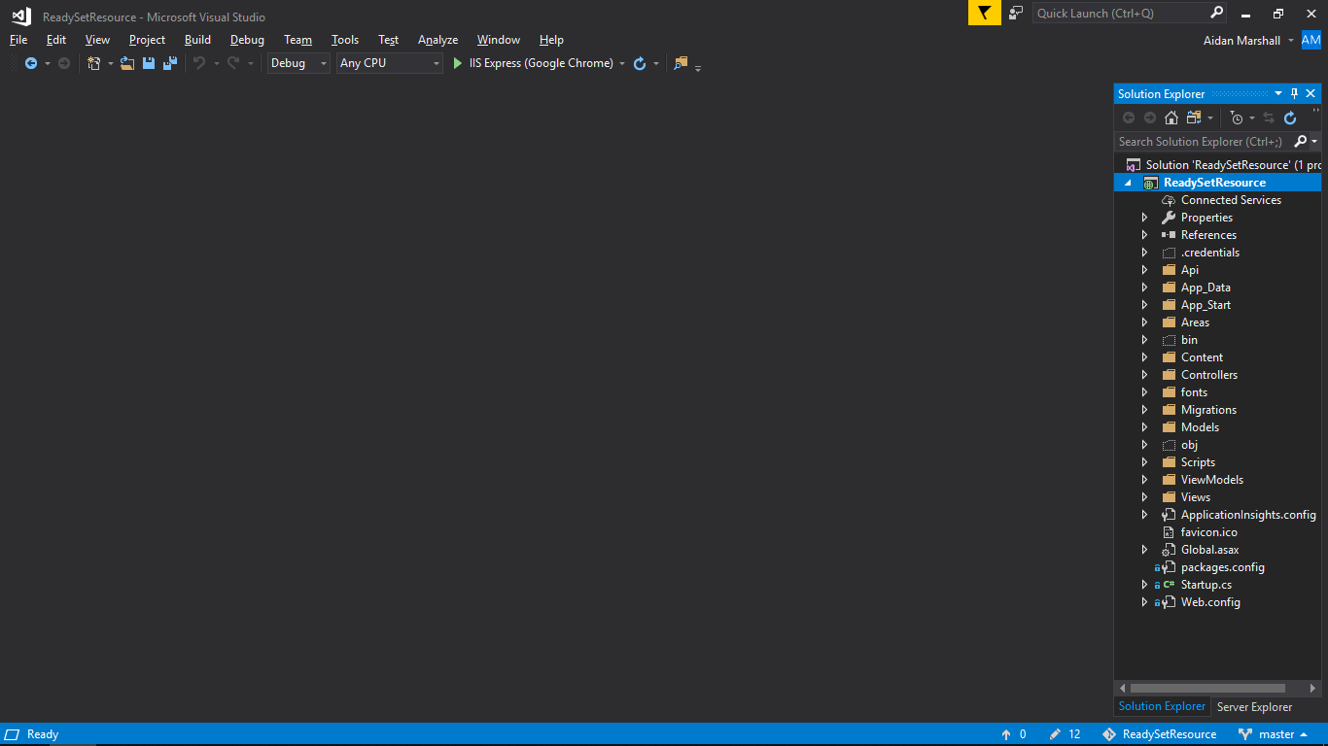

Screenshot After:

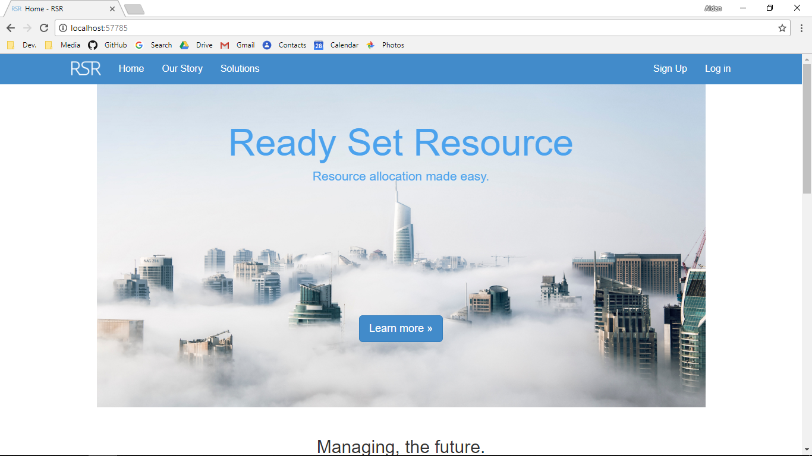

Additional Screenshot (if applicable):

Additional Notes (if applicable):

Test Case ID: HR2 Attempt Number: 1

Action: The user clicks on ‘credits’ on the footer

Comprehensive Test Type: Not Applicable

Test Data: Not Applicable

Expected Output: The user is redirected to the credits page and sees credits and sources

Actual Output: As expected

Result: Pass

Reason for fail (if applicable):

Error Type (if applicable):

Remediation (if applicable):

Screenshot Before:

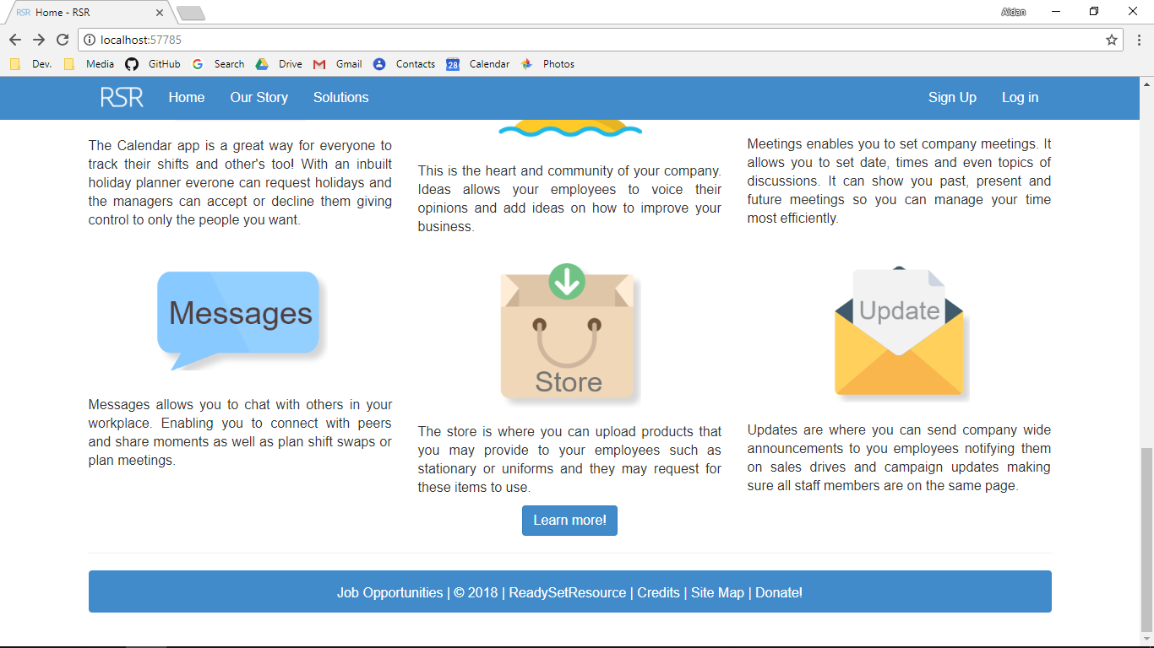

Screenshot After:

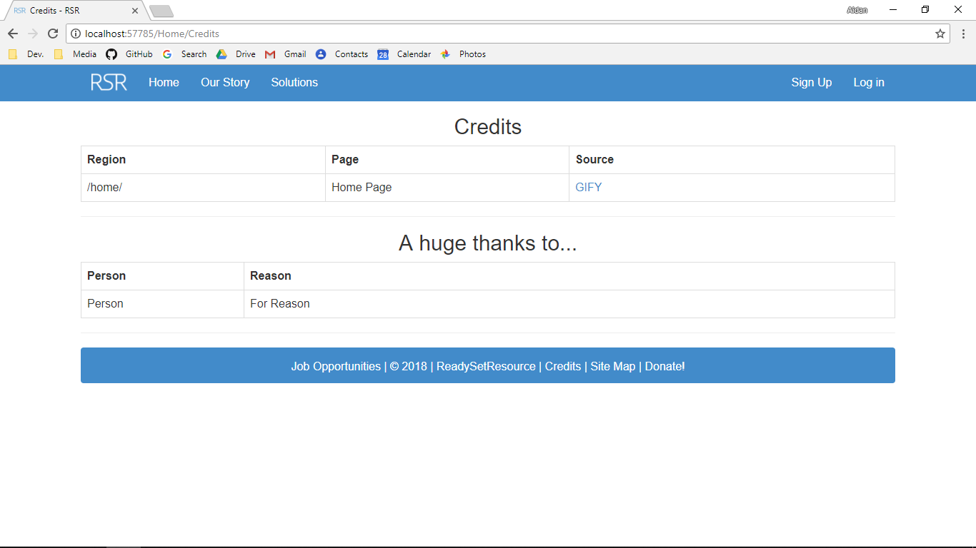

Additional Screenshot (if applicable):

Additional Notes (if applicable):

Test Case ID: HL1 Attempt Number: 1

Action: The user clicks on the Logo

Comprehensive Test Type: Not Applicable

Test Data: Not Applicable

Expected Output: The user is redirected to the home page

Actual Output: As expected

Result: Pass

Reason for fail (if applicable):

Error Type (if applicable):

Remediation (if applicable):

Screenshot Before:



Screenshot After:



Additional Screenshot (if applicable):

Additional Notes (if applicable):

Test Case ID: HL2 Attempt Number: 1

Action: The user clicks on the home button

Comprehensive Test Type: Not Applicable

Test Data: Not Applicable

Expected Output: The user is redirected to the index page of the home controller

Actual Output: As expected

Result: Pass

Reason for fail (if applicable):

Error Type (if applicable):

Remediation (if applicable):

Screenshot Before:



Screenshot After:



Additional Screenshot (if applicable):

Additional Notes (if applicable):

Test Case ID: HL3 Attempt Number: 1

Action: The user clicks on the Our Story button

Comprehensive Test Type: Not Applicable

Test Data: Not Applicable

Expected Output: The user is redirected to the Our Story page in the home controller

Actual Output: As expected

Result: Pass

Reason for fail (if applicable):

Error Type (if applicable):

Remediation (if applicable):

Screenshot Before:



Screenshot After:

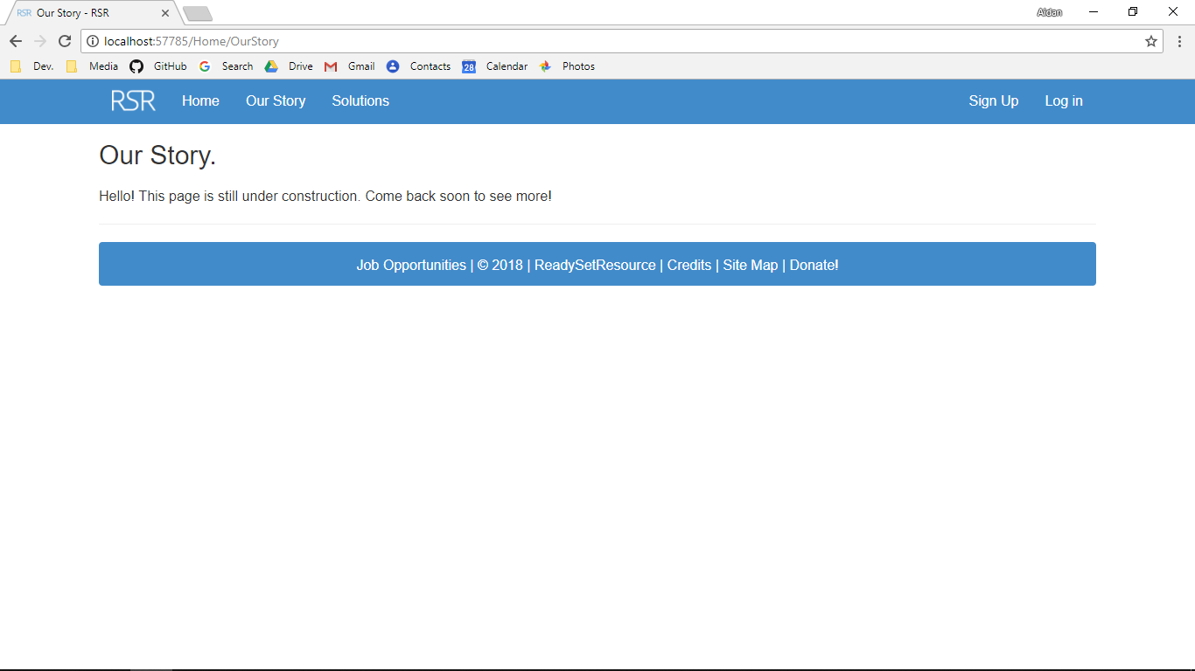

Additional Screenshot (if applicable):

Additional Notes (if applicable):

Test Case ID: HL4 Attempt Number: 1

Action: The user clicks on the Solutions button

Comprehensive Test Type: Not Applicable

Test Data: Not Applicable

Expected Output: The user is redirected to the solutions page

Actual Output: As expected

Result: Pass

Reason for fail (if applicable):

Error Type (if applicable):

Remediation (if applicable):

Screenshot Before:



Screenshot After:

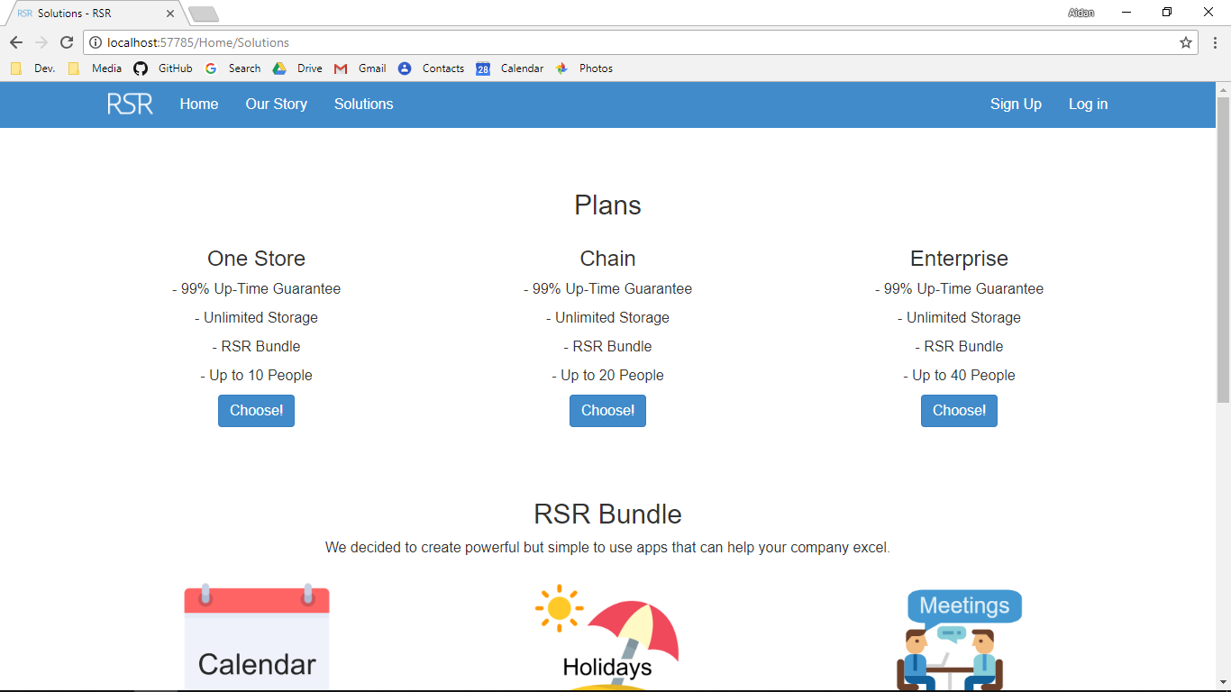

Additional Screenshot (if applicable):

Additional Notes (if applicable):

Test Case ID: HL5 Attempt Number: 1

Action: The user clicks on the Sign Up page

Comprehensive Test Type: Not Applicable

Test Data: Not Applicable

Expected Output: The user is redirected to the solutions page in the get controller

Actual Output: As expected

Result: Pass

Reason for fail (if applicable):

Error Type (if applicable):

Remediation (if applicable):

Screenshot Before:



Screenshot After:

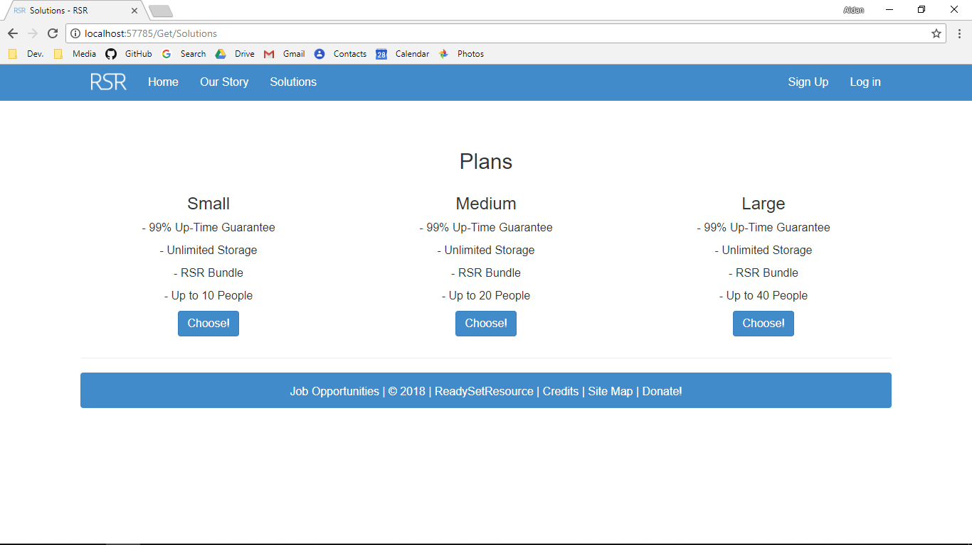

Additional Screenshot (if applicable):

Additional Notes (if applicable):

Test Case ID: HL6 Attempt Number: 1

Action: The user clicks on the log in page

Comprehensive Test Type: Not Applicable

Test Data: Not Applicable

Expected Output: The user is redirected to the log in page

Actual Output: As expected

Result: Pass

Reason for fail (if applicable):

Error Type (if applicable):

Remediation (if applicable):

Screenshot Before:



Screenshot After:

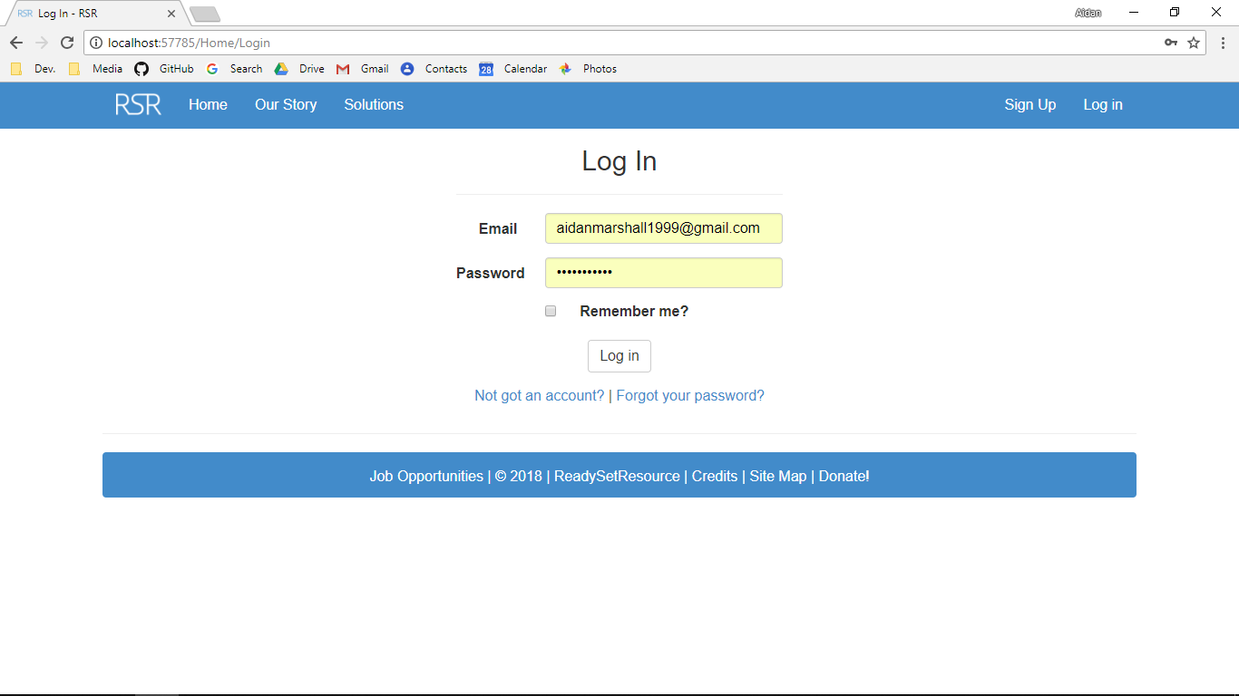

Additional Screenshot (if applicable):

Additional Notes (if applicable):

Test Case ID: HL7 Attempt Number: 1

Action: The user clicks on the Launch Dashboard button on the index page (must log in first)

Comprehensive Test Type: Not Applicable

Test Data: Not Applicable

Expected Output: The user is redirected to the index page in the dashboard controller

Actual Output: As expected

Result: Pass

Reason for fail (if applicable):

Error Type (if applicable):

Remediation (if applicable):

Screenshot Before:

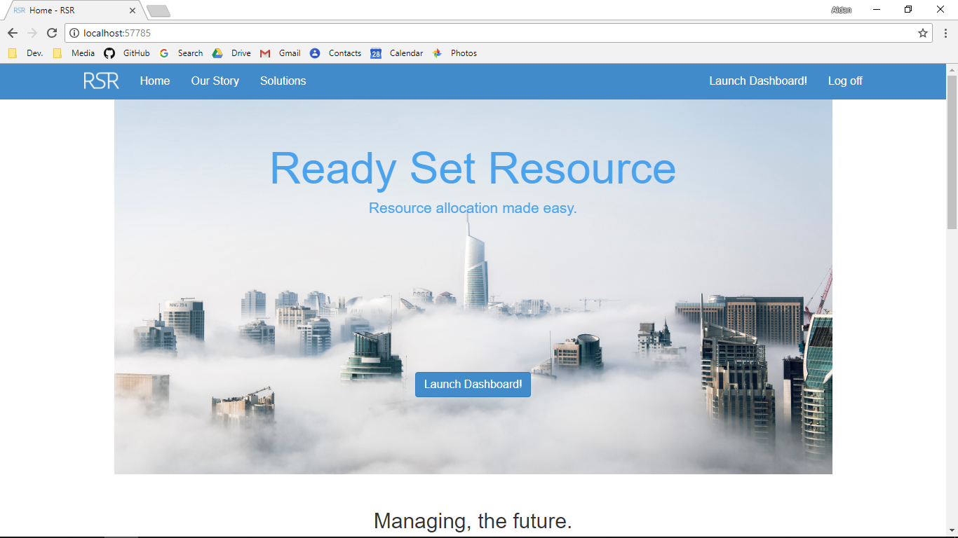

Screenshot After:

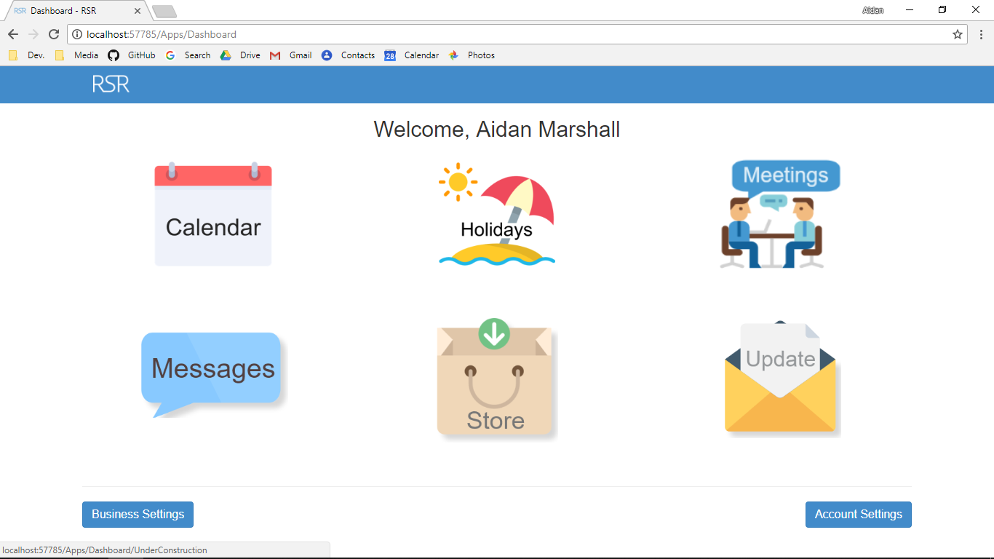

Additional Screenshot (if applicable):

Additional Notes (if applicable):

Test Case ID: HL8 Attempt Number: 1

Action: The user clicks on the Job Opportunities button

Comprehensive Test Type: Not Applicable

Test Data: Not Applicable

Expected Output: The user is redirected to the Job Opportunities page

Actual Output: As expected

Result: Pass

Reason for fail (if applicable):

Error Type (if applicable):

Remediation (if applicable):

Screenshot Before:

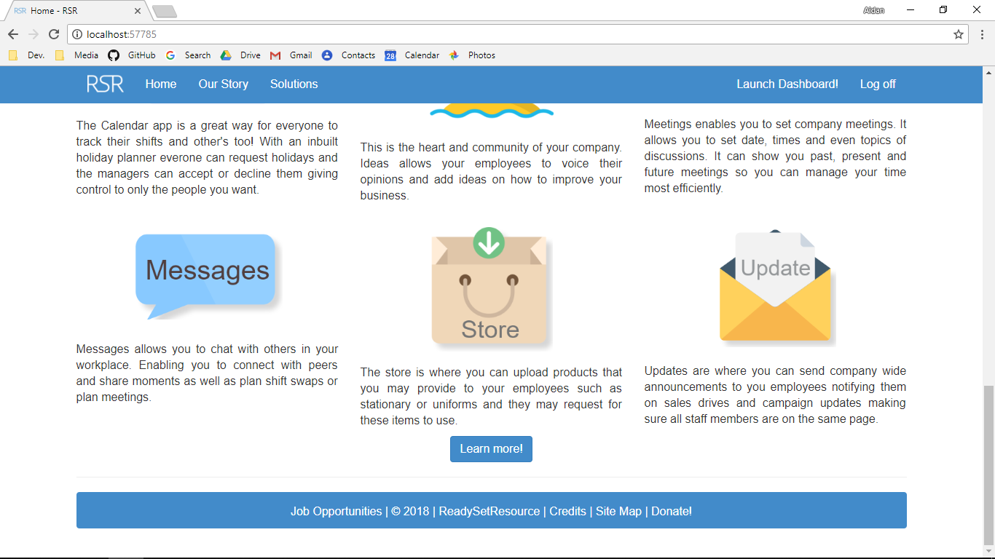

Screenshot After:

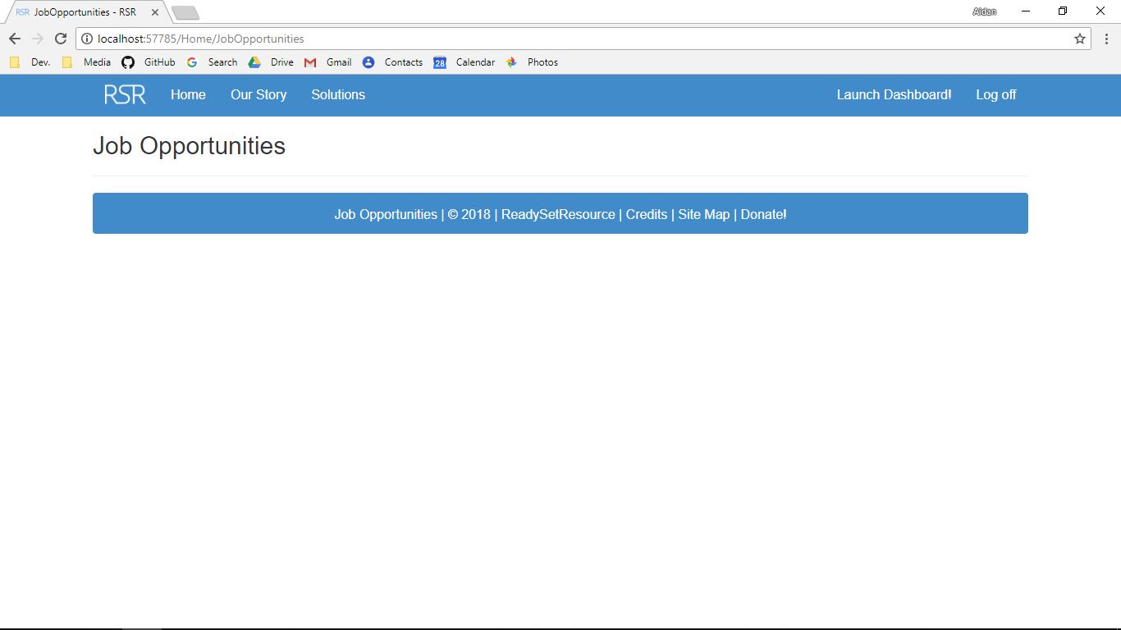

Additional Screenshot (if applicable):

Additional Notes (if applicable):

Test Case ID: HL9 Attempt Number: 1

Action: The user clicks on the 2018 button

Comprehensive Test Type: Not Applicable

Test Data: Not Applicable

Expected Output: The user is redirected to the legal index page

Actual Output: As expected

Result: Pass

Reason for fail (if applicable):

Error Type (if applicable):

Remediation (if applicable):

Screenshot Before:

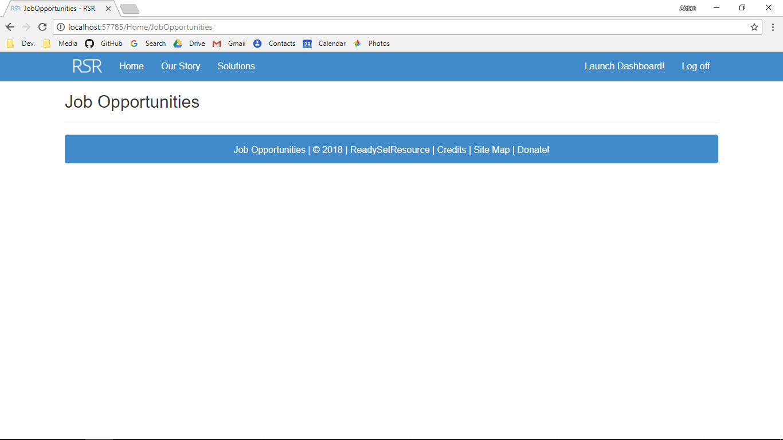

Screenshot After:

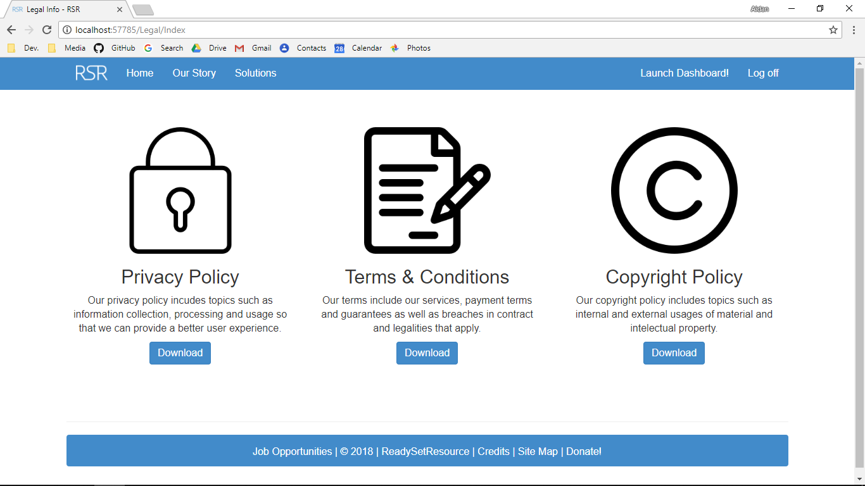

Additional Screenshot (if applicable):

Additional Notes (if applicable):

Test Case ID: HL10 Attempt Number: 1

Action: The user clicks on ReadySetResource button

Comprehensive Test Type: Not Applicable

Test Data: Not Applicable

Expected Output: The user is redirected to the index page in the home controller

Actual Output: As expected

Result: Pass

Reason for fail (if applicable):

Error Type (if applicable):

Remediation (if applicable):

Screenshot Before:



Screenshot After:



Additional Screenshot (if applicable):

Additional Notes (if applicable):

Test Case ID: HL11 Attempt Number: 1

Action: The user clicks on the credits button

Comprehensive Test Type: Not Applicable

Test Data: Not Applicable

Expected Output: The user is redirected to the credits page

Actual Output: As expected

Result: Pass

Reason for fail (if applicable):

Error Type (if applicable):

Remediation (if applicable):

Screenshot Before:

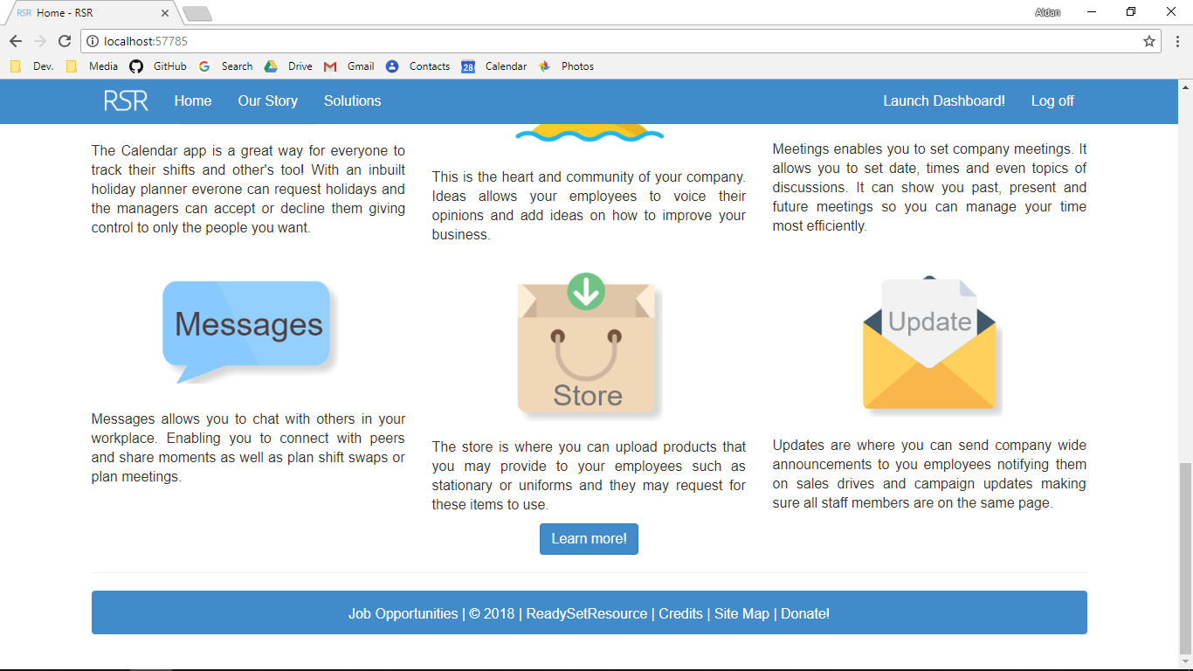

Screenshot After:

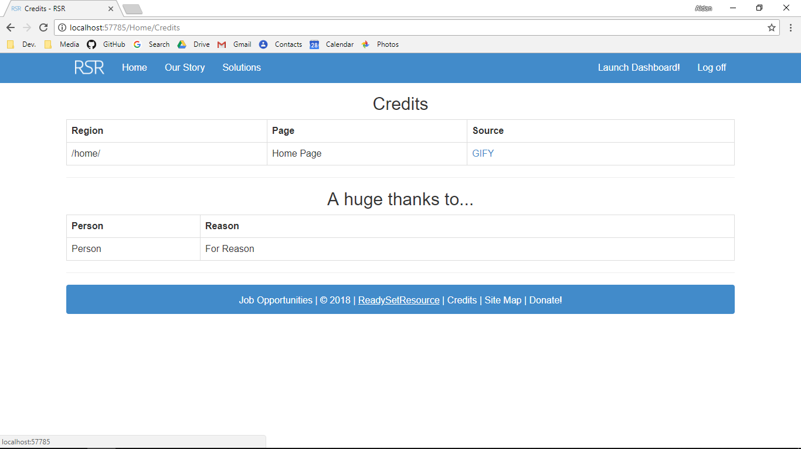

Additional Screenshot (if applicable):

Additional Notes (if applicable):

Test Case ID: HL12 Attempt Number: 1

Action: The user clicks on the Site Map Button

Comprehensive Test Type: Not Applicable

Test Data: Not Applicable

Expected Output: The user is redirected to the site map page

Actual Output: As expected

Result: Pass

Reason for fail (if applicable):

Error Type (if applicable):

Remediation (if applicable):

Screenshot Before:



Screenshot After:

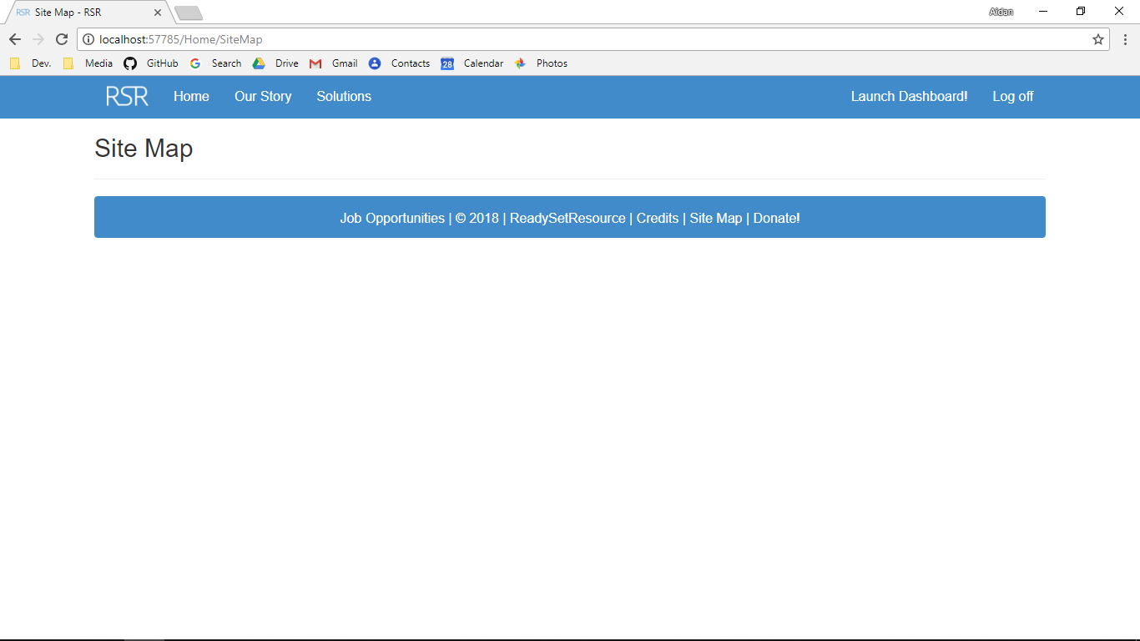

Additional Screenshot (if applicable):

Additional Notes (if applicable):

Test Case ID: HL13 Attempt Number: 1

Action: The user clicks on the Donate! button

Comprehensive Test Type: Not Applicable

Test Data: Not Applicable

Expected Output: The user is redirected to the donate page

Actual Output: As expected

Result: Pass

Reason for fail (if applicable):

Error Type (if applicable):

Remediation (if applicable):

Screenshot Before:



Screenshot After:

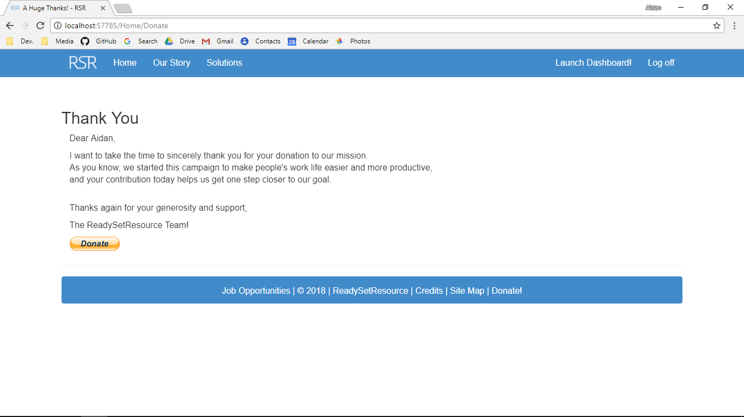

Additional Screenshot (if applicable):

Additional Notes (if applicable):

Test Case ID: HL14 Attempt Number: 1

Action: The user clicks on the learn more >> button

Comprehensive Test Type: Not Applicable

Test Data: Not Applicable

Expected Output: The user is redirected to the Future of Managing section of the index page of the home controller

Actual Output: Not as expected.

Result: Fail

Reason for fail (if applicable): View additional screenshot for what the output should have been. As it is only a small design flaw, remediations are not necessary.

Error Type (if applicable): Design

Remediation (if applicable): None

Screenshot Before:



Screenshot After:

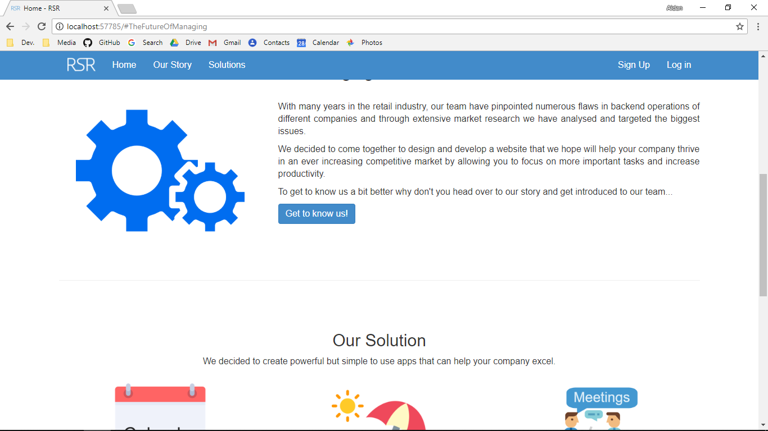

Additional Screenshot (if applicable):

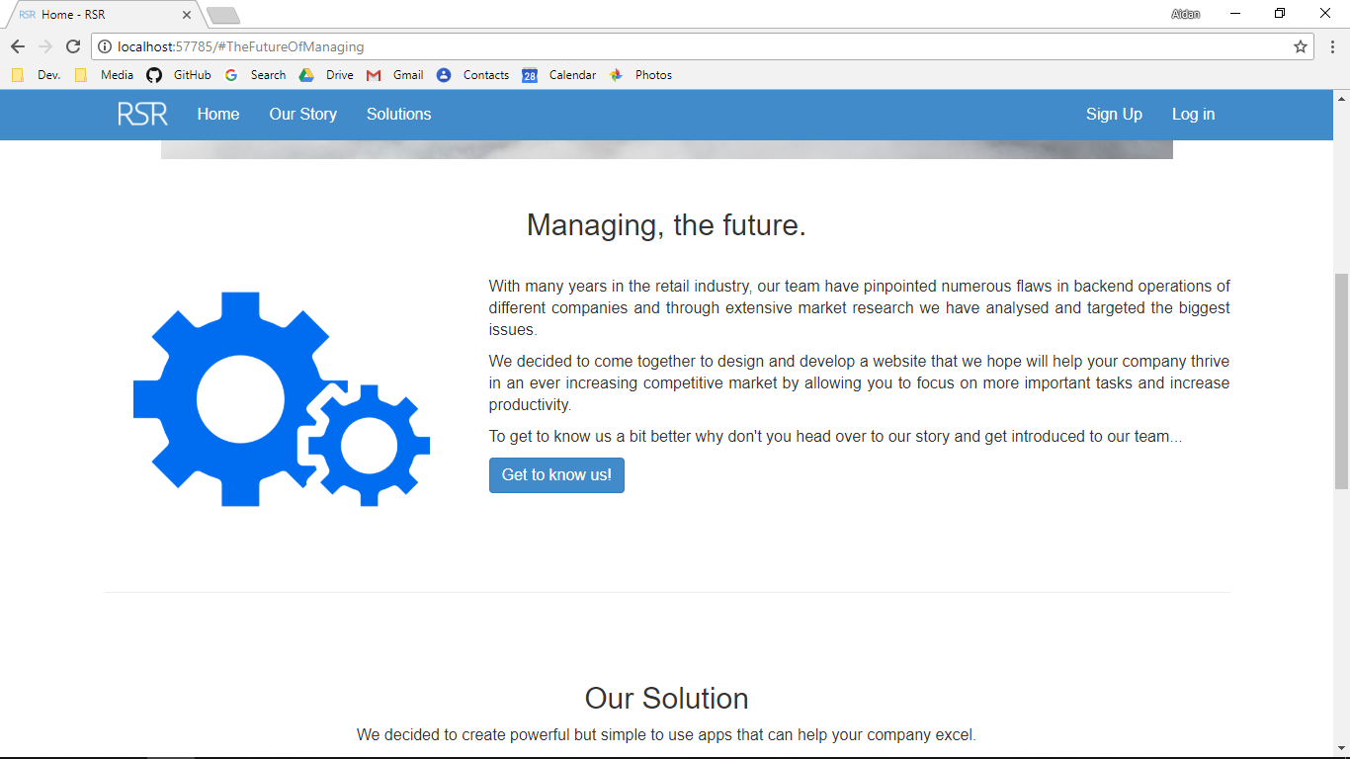

Additional Notes (if applicable):

Test Case ID: HL15 Attempt Number: 1

Action: The user clicks on the Get to Know Us! button

Comprehensive Test Type: Not Applicable

Test Data: Not Applicable

Expected Output: The user is redirected to the Our story page

Actual Output: As expected

Result: Pass

Reason for fail (if applicable):

Error Type (if applicable):

Remediation (if applicable):

Screenshot Before:



Screenshot After:



Additional Screenshot (if applicable):

Additional Notes (if applicable):

Test Case ID: HL16 Attempt Number: 1

Action: The user clicks on the learn more! button

Comprehensive Test Type: Not Applicable

Test Data: Not Applicable

Expected Output: The user is redirected to the solutions page

Actual Output: As expected

Result: Pass

Reason for fail (if applicable):

Error Type (if applicable):

Remediation (if applicable):

Screenshot Before:

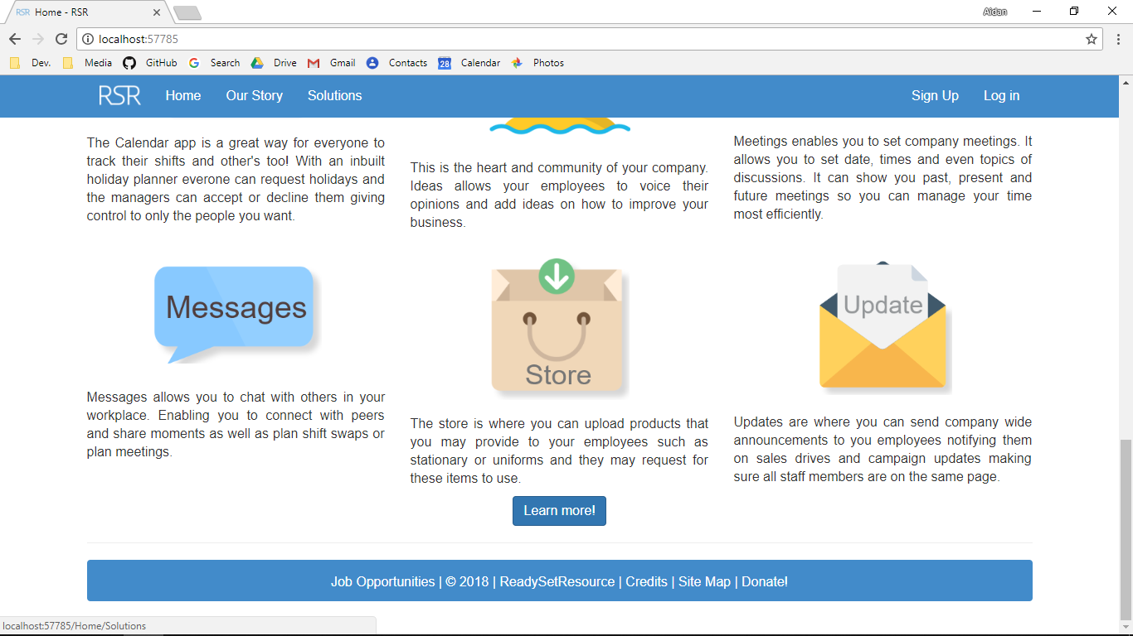

Screenshot After:

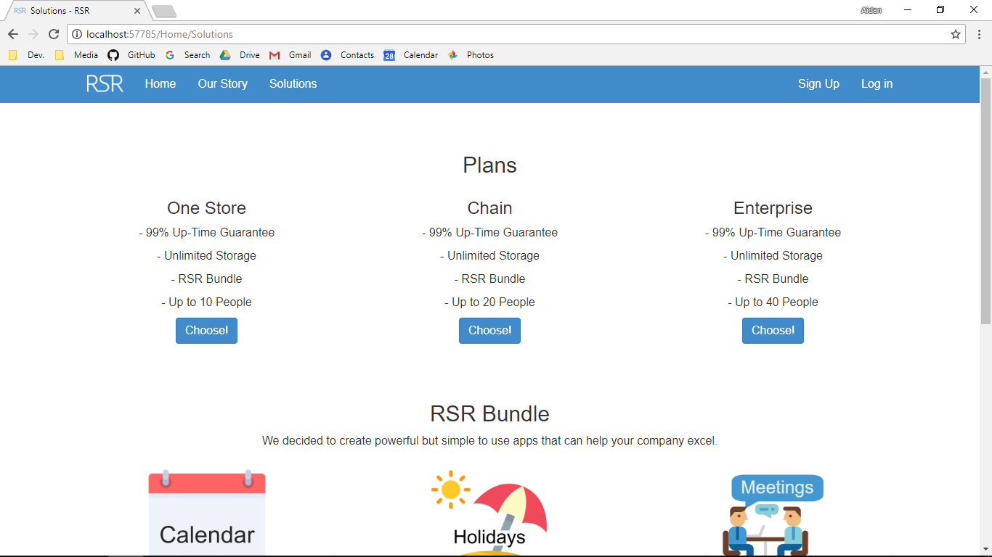

Additional Screenshot (if applicable):

Additional Notes (if applicable):

Test Case ID: HL17 Attempt Number: 1

Action: The user clicks the first choose button

Comprehensive Test Type: Not Applicable

Test Data: Not Applicable

Expected Output: The user is redirected to the business info page with the plan variable being passed in set to 1

Actual Output: As expected

Result: Pass

Reason for fail (if applicable):

Error Type (if applicable):

Remediation (if applicable):

Screenshot Before:



Screenshot After:

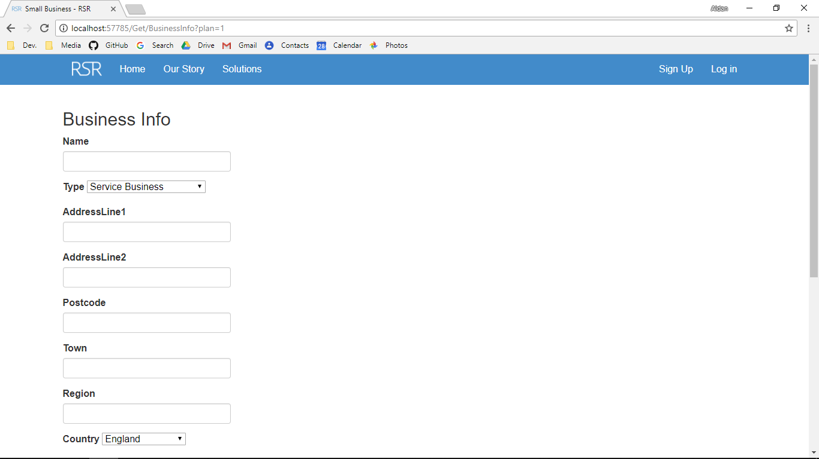

Additional Screenshot (if applicable):

Additional Notes (if applicable):

Test Case ID: HL18 Attempt Number: 1

Action: The user clicks the second choose button

Comprehensive Test Type: Not Applicable

Test Data: Not Applicable

Expected Output: The user is redirected to the business info page with the plan variable being passed in set to 2

Actual Output: As expected

Result: Pass

Reason for fail (if applicable):

Error Type (if applicable):

Remediation (if applicable):

Screenshot Before:



Screenshot After:

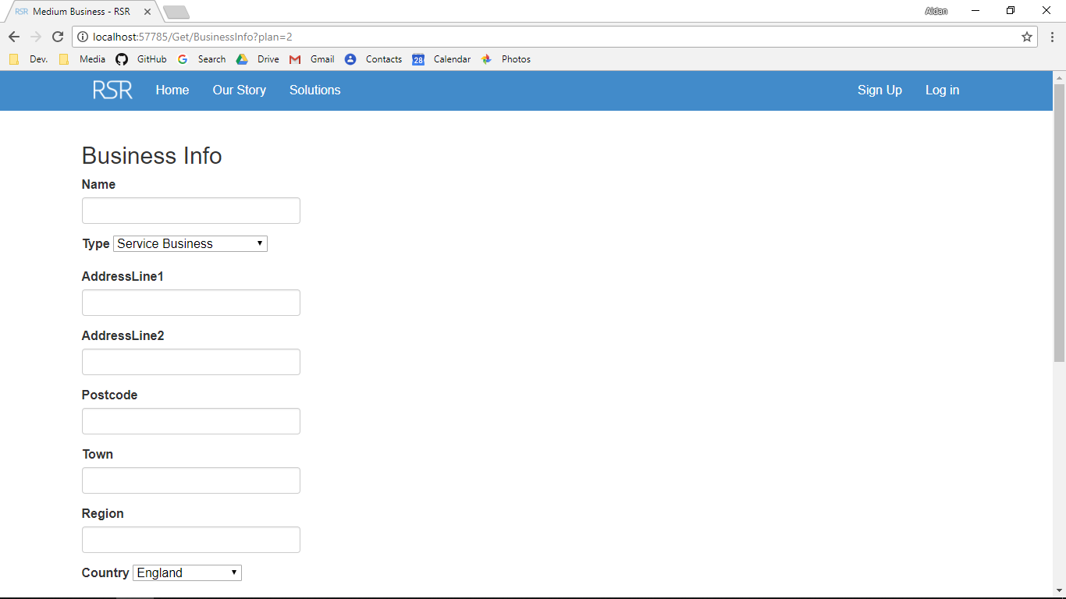

Additional Screenshot (if applicable):

Additional Notes (if applicable):

Test Case ID: HL19 Attempt Number: 1

Action: The user clicks the third choose button

Comprehensive Test Type: Not Applicable

Test Data: Not Applicable

Expected Output: The user is redirected to the business info page with the plan variable being passed in set to 3

Actual Output: As expected

Result: Pass

Reason for fail (if applicable):

Error Type (if applicable):

Remediation (if applicable):

Screenshot Before:



Screenshot After:

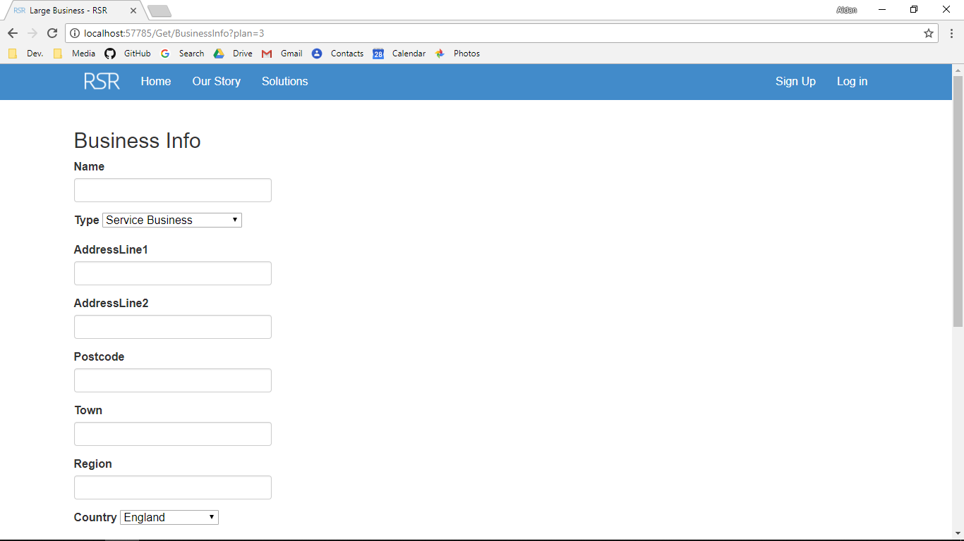

Additional Screenshot (if applicable):

Additional Notes (if applicable):

Test Case ID: HL20 Attempt Number: 1

Action: The user clicks on the Not got an account? button

Comprehensive Test Type: Not Applicable

Test Data: Not Applicable

Expected Output: The user is redirected to the solutions page in the get controller

Actual Output: As expected

Result: Pass

Reason for fail (if applicable):

Error Type (if applicable):

Remediation (if applicable):

Screenshot Before:

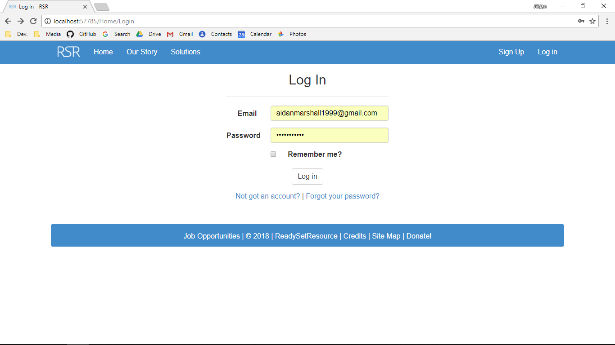

Screenshot After:



Additional Screenshot (if applicable):

Additional Notes (if applicable):

Test Case ID: HL21 Attempt Number: 1

Action: The user clicks on the Forgot your Password? button

Comprehensive Test Type: Not Applicable

Test Data: Not Applicable

Expected Output: The user is redirected to the forgot password page

Actual Output: As expected

Result: Pass

Reason for fail (if applicable):

Error Type (if applicable):

Remediation (if applicable):

Screenshot Before:



Screenshot After:

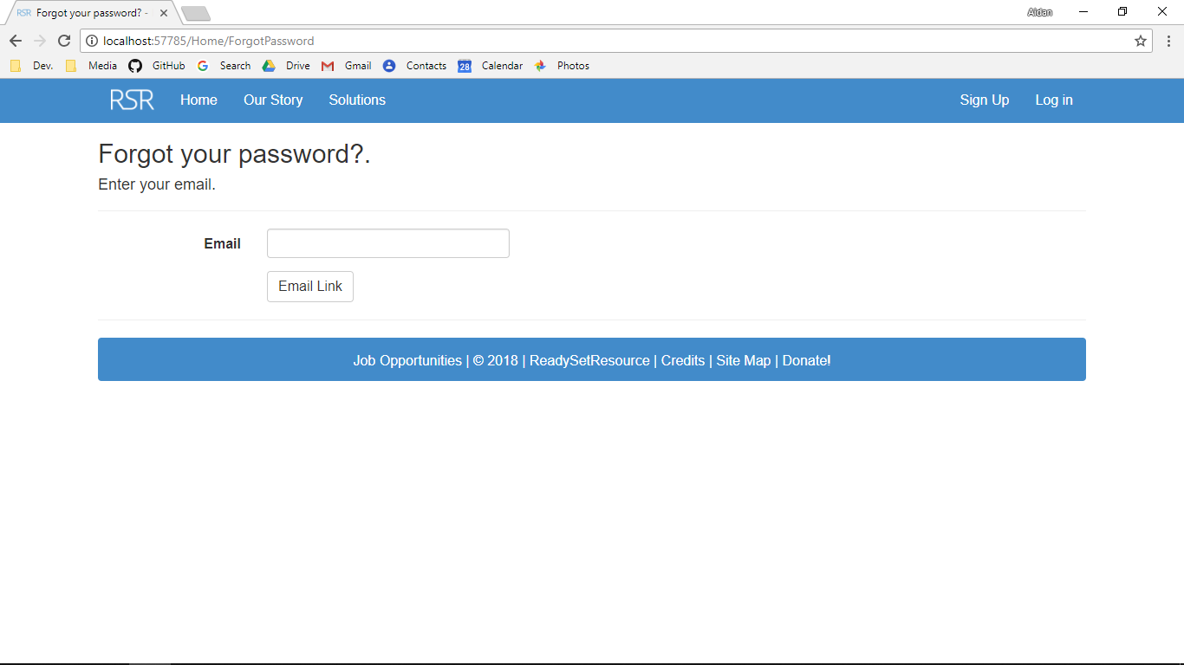

Additional Screenshot (if applicable):

Additional Notes (if applicable):

Test Case ID: HA1 Attempt Number: 1

Action: The user clicks the Log off button

Comprehensive Test Type: Not Applicable

Test Data: Not Applicable

Expected Output: The user is logged off

Actual Output: As expected

Result: Pass

Reason for fail (if applicable):

Error Type (if applicable):

Remediation (if applicable):

Screenshot Before:

Screenshot After:

Additional Screenshot (if applicable):

Additional Notes (if applicable):

Test Case ID: HA3 Attempt Number: 1

Action: The user clicks Email Link button after adding their email address

Comprehensive Test Type: Normal

Test Data: Email: [aidanmarshall1999@gmail.com](mailto:aidanmarshall1999@gmail.com)

Expected Output: An email is sent and the user can reset password

Actual Output: As expected

Result: Fail

Reason for fail (if applicable): Authentication Failure

Error Type (if applicable): Execution

Remediation (if applicable): VPN service was turned off

Screenshot Before:

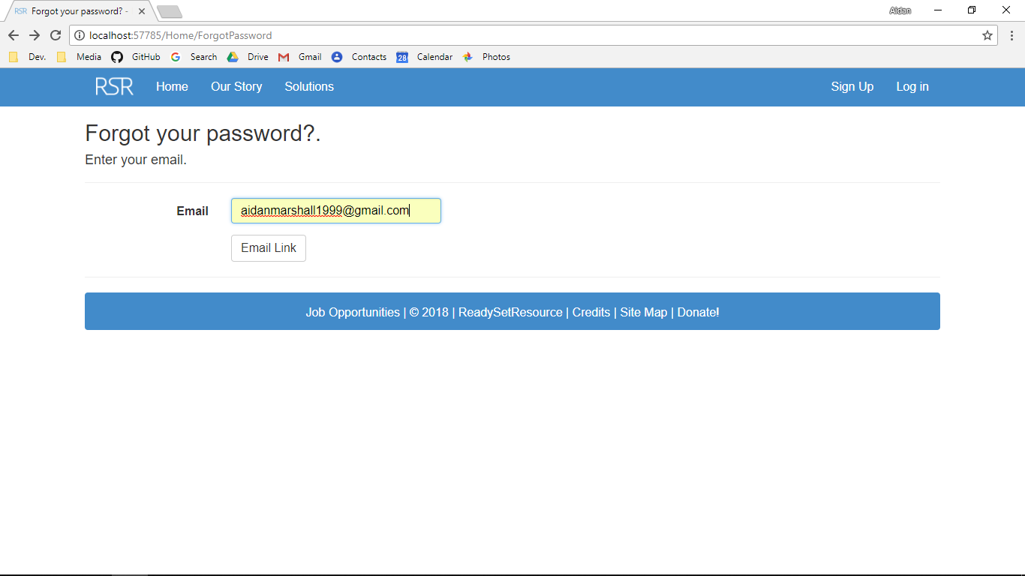

Screenshot After:

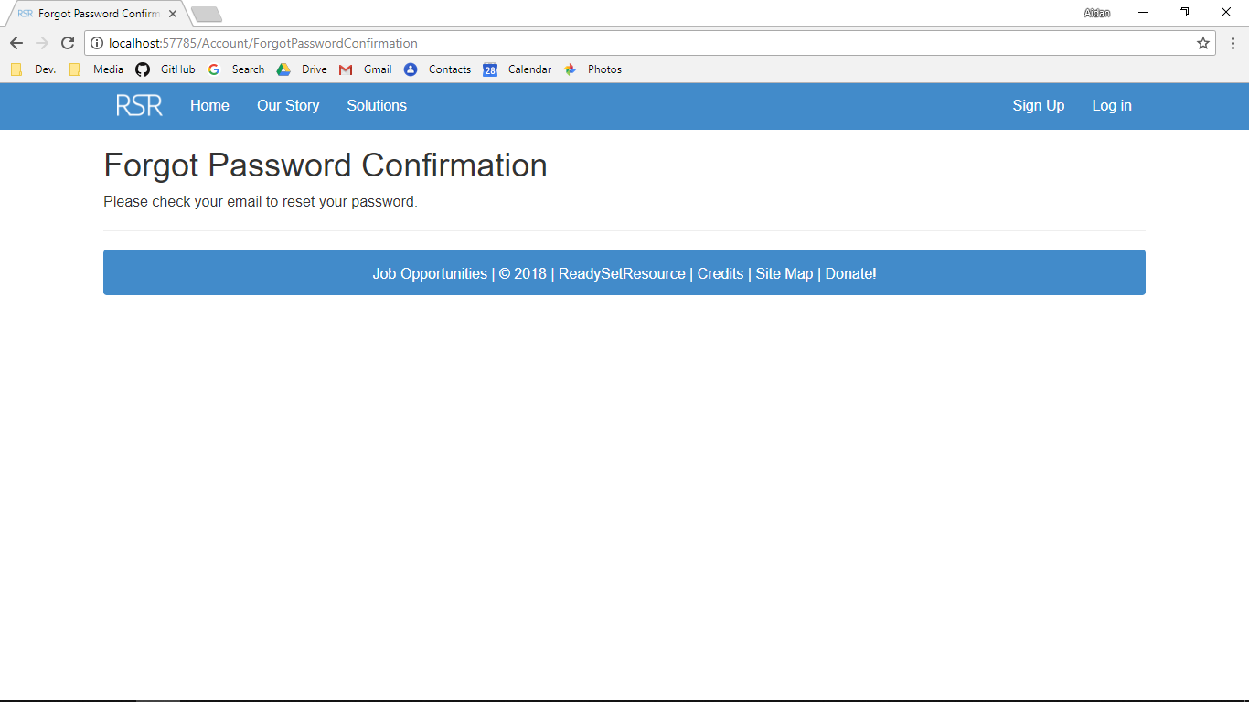

Additional Screenshot (if applicable):

Additional Notes (if applicable):

Test Case ID: HA3 Attempt Number: 1

Action: The user clicks Email Link button after adding their email address

Comprehensive Test Type: Normal

Test Data: Email: [aidanmarshall1999@gmail.com](mailto:aidanmarshall1999@gmail.com)

Expected Output: An email is sent and the user can reset password

Actual Output: As expected

Result: Fail

Reason for fail (if applicable): Authentication Failure

Error Type (if applicable): Execution

Remediation (if applicable): VPN service was turned off

Screenshot Before:



Screenshot After:

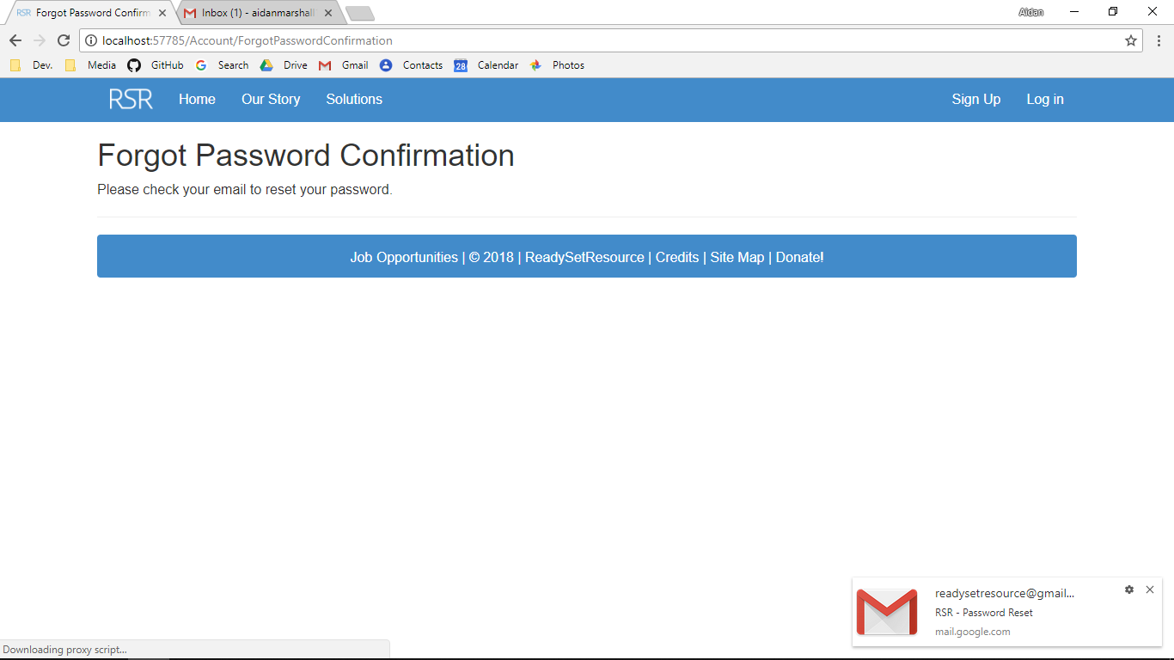

Additional Screenshot (if applicable):

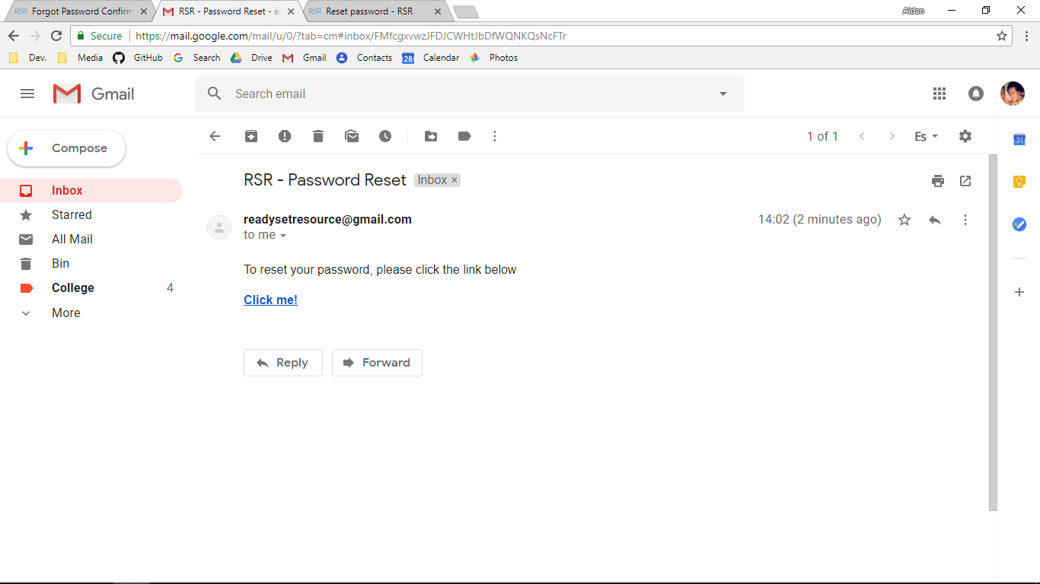

Additional Notes (if applicable):

Test Case ID: HA3 Attempt Number: 1

Action: The user clicks Email Link button after adding their email address

Comprehensive Test Type: Exceptional

Test Data: Email: [marshallaidan1999@gmail.com](mailto:marshallaidan1999@gmail.com)

Expected Output: An email is not sent as that user does not exist in the system and the user cannot reset password

Actual Output: As expected

Result: Pass

Reason for fail (if applicable):

Error Type (if applicable):

Remediation (if applicable):

Screenshot Before:

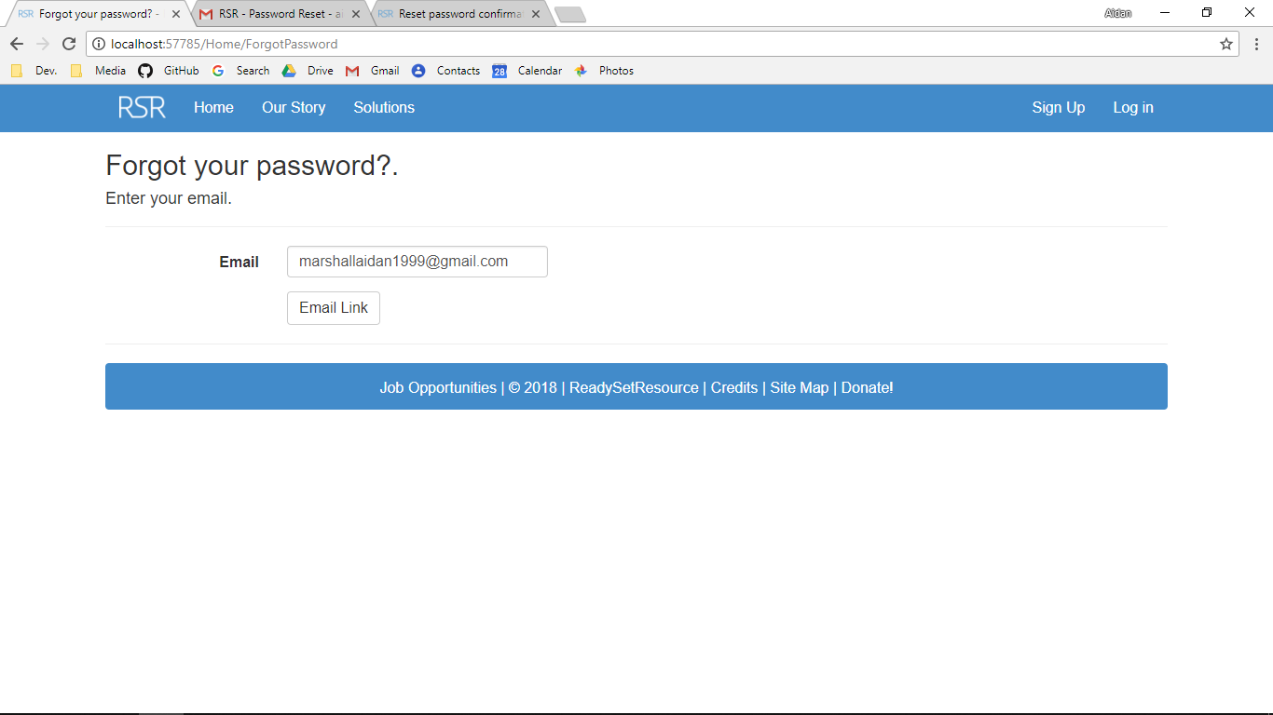

Screenshot After:

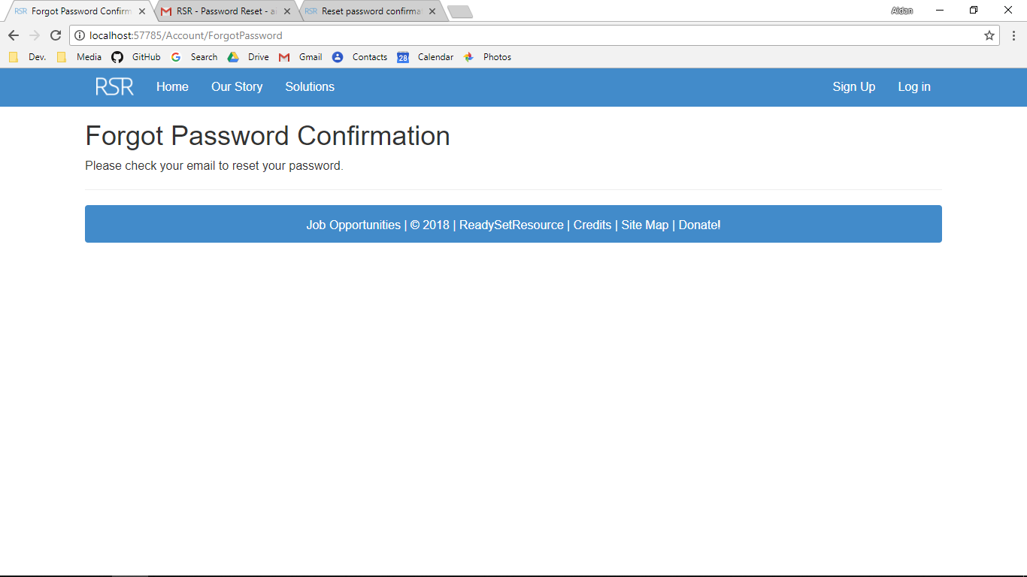

Additional Screenshot (if applicable):

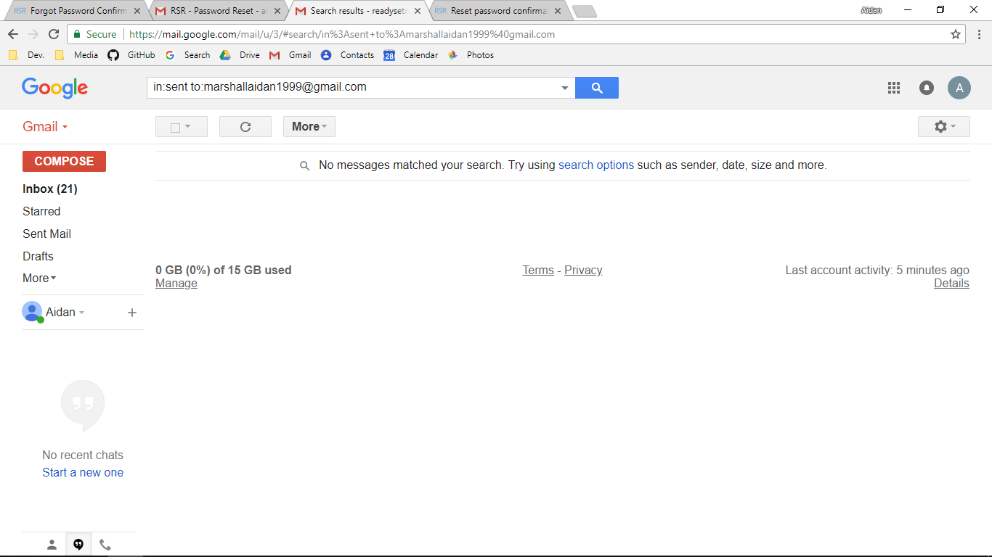

Additional Notes (if applicable):

Test Case ID: HA2 Attempt Number: 1

Action: The user clicks log in

Comprehensive Test Type: Normal

Test Data: Email: [aidanmarshall1999@gmail.com](mailto:aidanmarshall1999@gmail.com)

Password: HelloWorld1

Expected Output: The user is logged in

Actual Output: As expected

Result: Pass

Reason for fail (if applicable):

Error Type (if applicable):

Remediation (if applicable):

Screenshot Before:

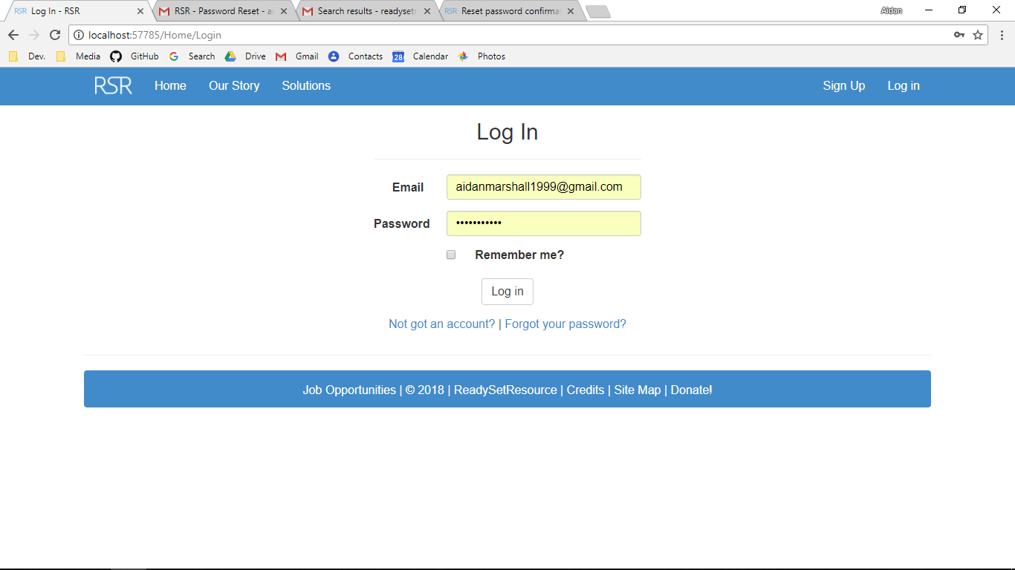

Screenshot After:

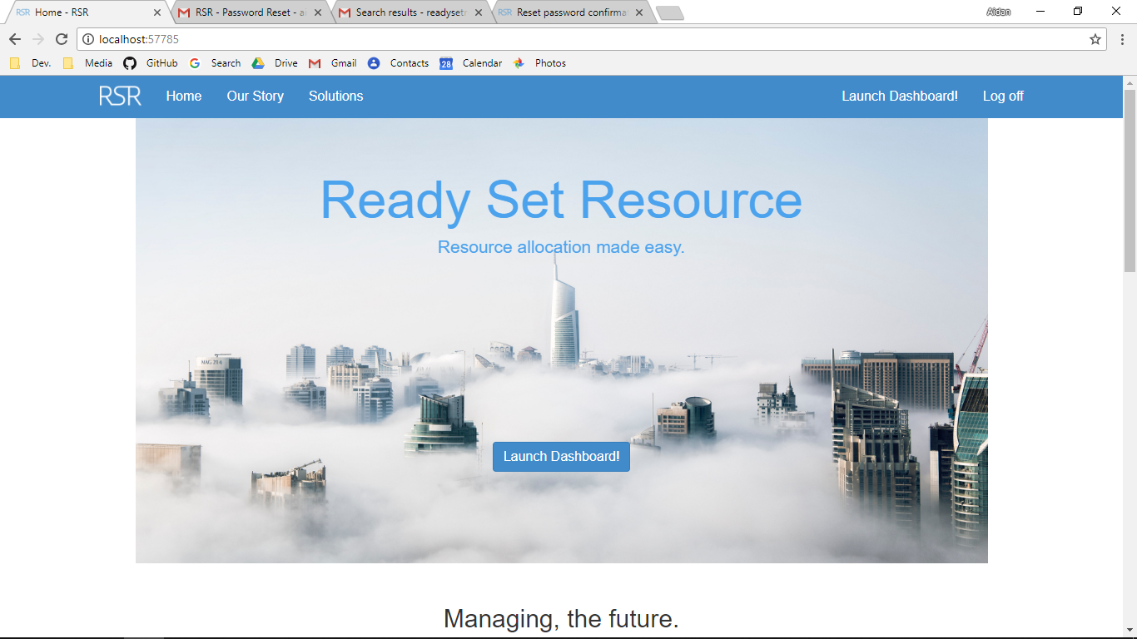

Additional Screenshot (if applicable):

Additional Notes (if applicable): The testing for the input validation will be in later test cases. This test ensures that if a user is in the system or not and be able to log the user in and therefore does not contain extreme.

Test Case ID: HA2 Attempt Number: 1

Action: The user clicks log in

Comprehensive Test Type: Exceptional

Test Data: Email: [johndoe@gmail.com](mailto:johndoe@gmail.com)

Password: JaneDoe7

Expected Output: The user is not logged in

Actual Output: As expected

Result: Pass

Reason for fail (if applicable):

Error Type (if applicable):

Remediation (if applicable):

Screenshot Before:

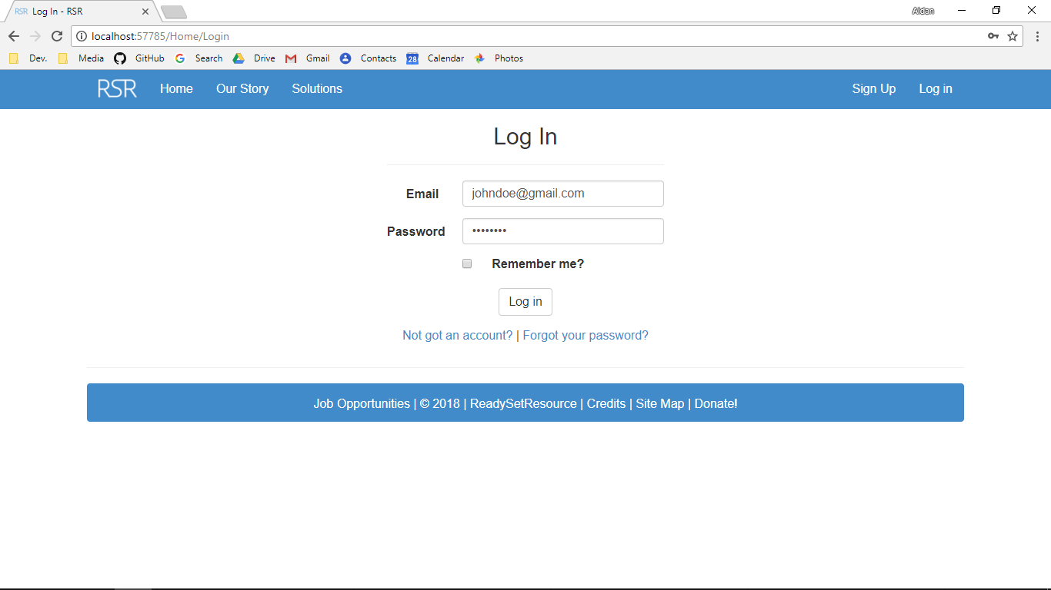

Screenshot After:

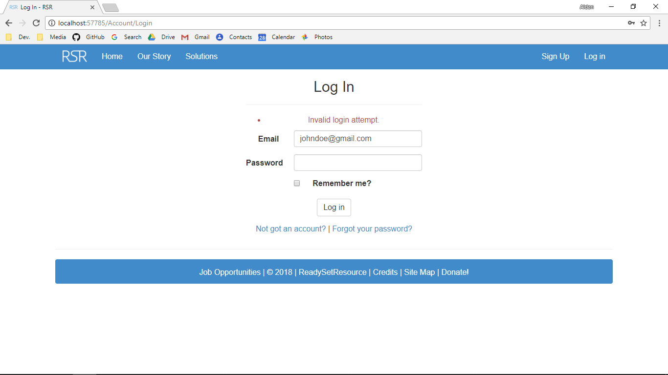

Additional Screenshot (if applicable):

Additional Notes (if applicable): The testing for the input validation will be in later test cases. This test ensures that if a user is in the system or not and be able to log the user in and therefore does not contain extreme.

Test Case ID: HV1 Attempt Number: 1

Action: The user inputs the email address and clicks log in

Comprehensive Test Type: Normal

Test Data: Email: [aidanmarshall@gmail.com](mailto:aidanmarshall@gmail.com)

Expected Output: The user logs in

Actual Output: As expected

Result: Pass

Reason for fail (if applicable):

Error Type (if applicable):

Remediation (if applicable):

Screenshot Before:



Screenshot After:



Additional Screenshot (if applicable):

Additional Notes (if applicable):

Test Case ID: HV1 Attempt Number: 1

Action: The user inputs the email address and clicks log in

Comprehensive Test Type: Extreme

Test Data: Email: [aidanm_1999@protonmail.com](mailto:aidanm_1999@protonmail.com)

Expected Output: The user logs in

Actual Output: As expected

Result: Pass

Reason for fail (if applicable):

Error Type (if applicable):

Remediation (if applicable):

Screenshot Before:

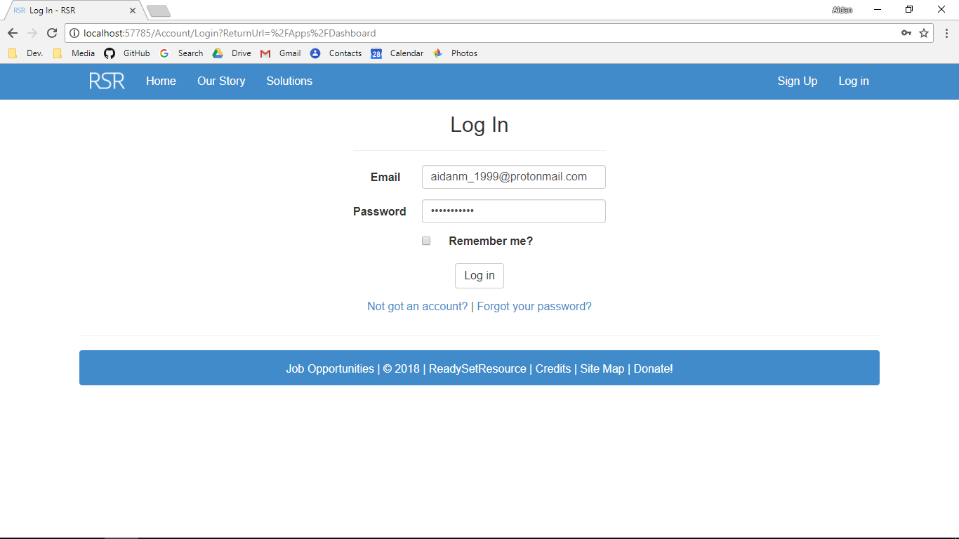

Screenshot After:



Additional Screenshot (if applicable):

Additional Notes (if applicable):

Test Case ID: HV1 Attempt Number: 1

Action: The user inputs the email address and clicks log in

Comprehensive Test Type: Exceptional

Test Data: Email: 182963

Expected Output: The user receives an error stating that the email address or password is incorrect

Actual Output: As expected

Result: Pass

Reason for fail (if applicable):

Error Type (if applicable):

Remediation (if applicable):

Screenshot Before:

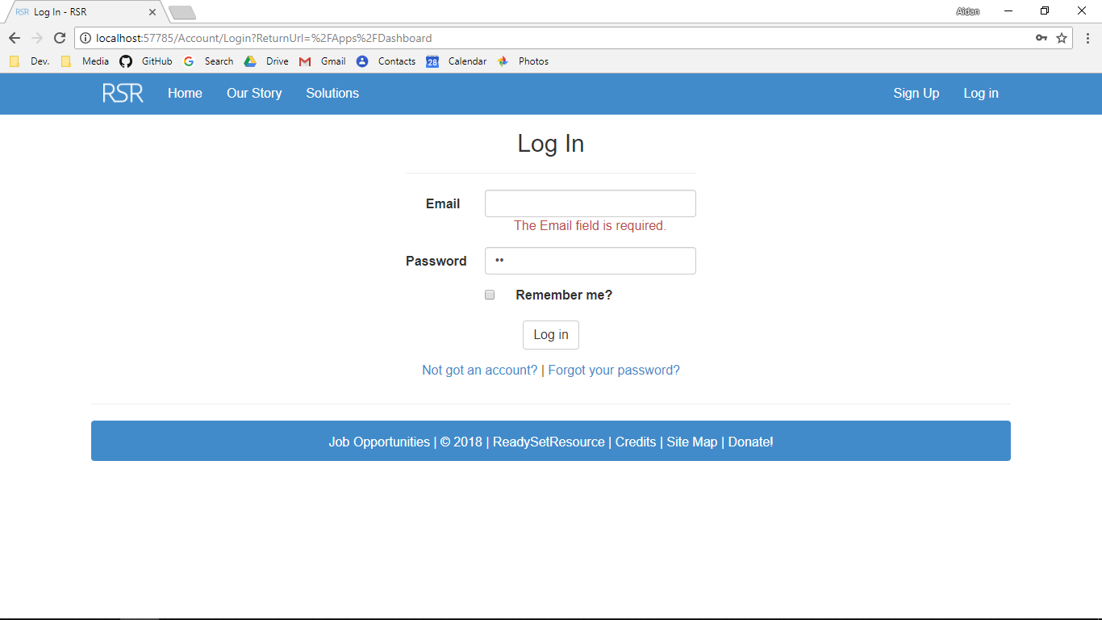

Screenshot After:

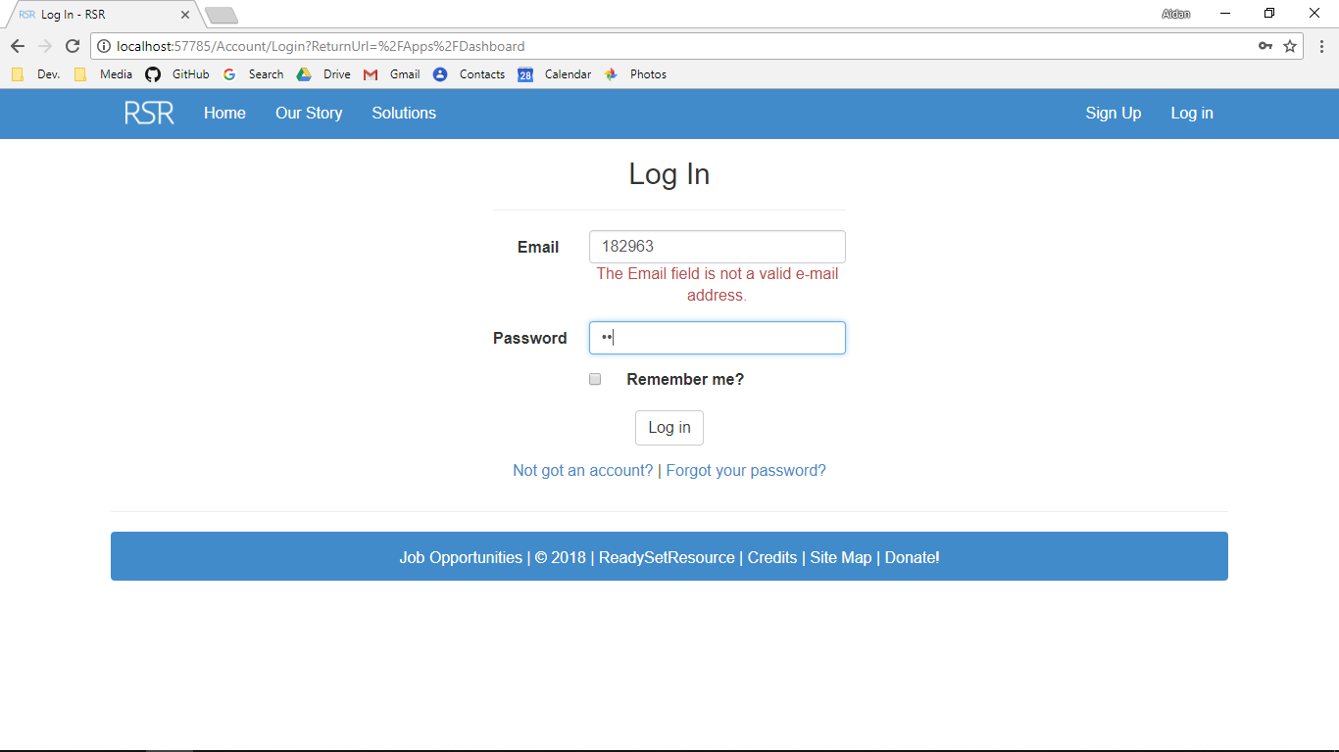

Additional Screenshot (if applicable):

Additional Notes (if applicable):

Test Case ID: HV2 Attempt Number: 1

Action: The user inputs the password and clicks log in

Comprehensive Test Type: Normal

Test Data: Password: HelloWorld1

Expected Output: The user logs in and is redirected to the index

Actual Output: As expected

Result: Pass

Reason for fail (if applicable):

Error Type (if applicable):

Remediation (if applicable):

Screenshot Before:

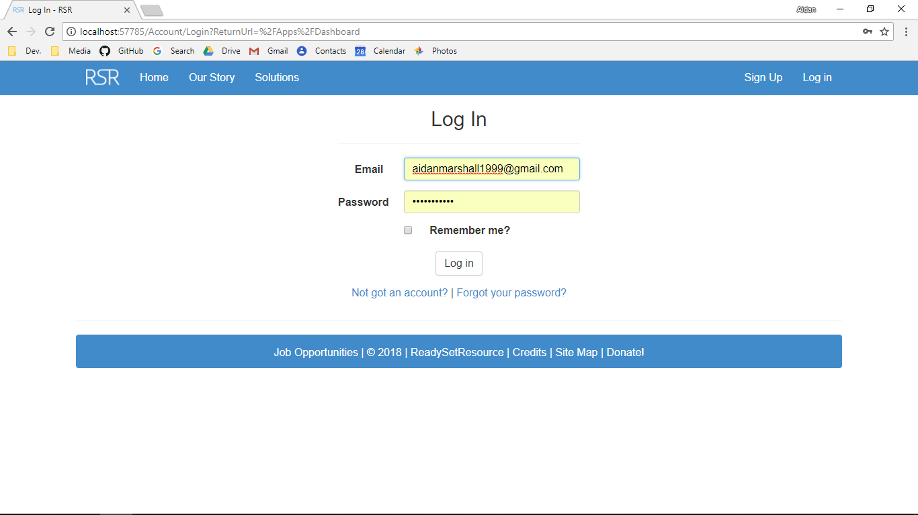

Screenshot After:



Additional Screenshot (if applicable):

Additional Notes (if applicable):

Test Case ID: HV2 Attempt Number: 1

Action: The user inputs the password and clicks log in

Comprehensive Test Type: Extreme

Test Data: Password: xI6V#yyZZ*

Expected Output: The user logs in

Actual Output: As expected

Result: Pass

Reason for fail (if applicable):

Error Type (if applicable):

Remediation (if applicable):

Screenshot Before:

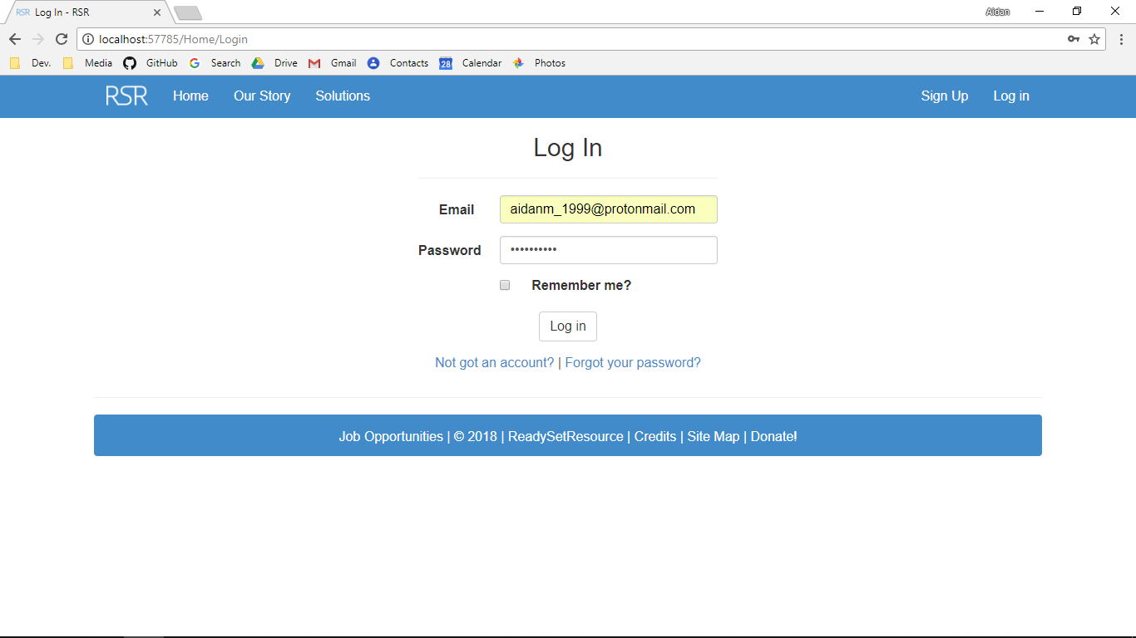

Screenshot After:



Additional Screenshot (if applicable):

Additional Notes (if applicable):

Test Case ID: HV2 Attempt Number: 1

Action: The user inputs the password and clicks log in

Comprehensive Test Type: Exceptional

Test Data: Password: /?\|$%^&””`¬

Expected Output: The user receives an error stating that the email address or password is incorrect

Actual Output: As expected

Result: Pass

Reason for fail (if applicable):

Error Type (if applicable):

Remediation (if applicable):

Screenshot Before:

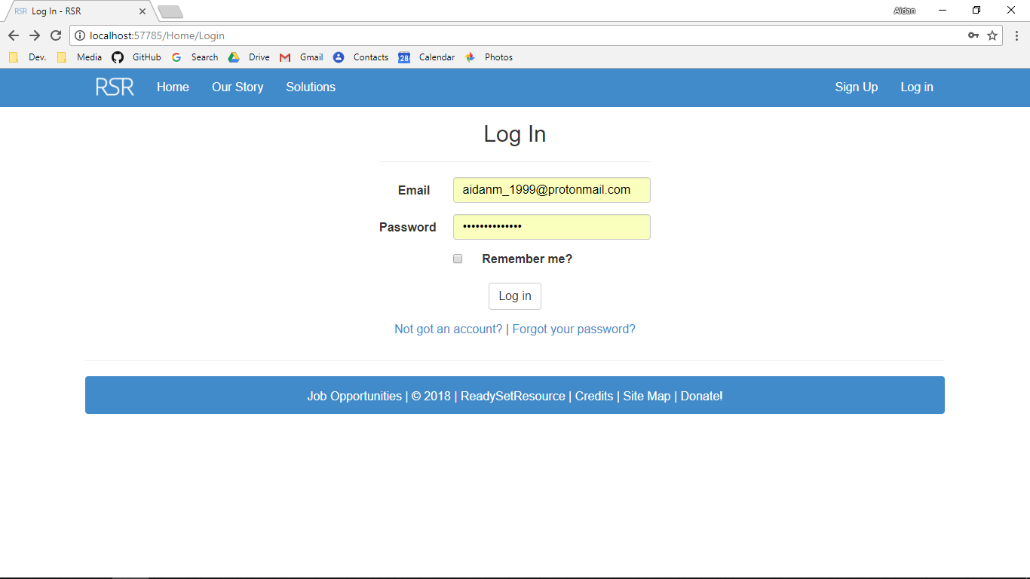

Screenshot After:

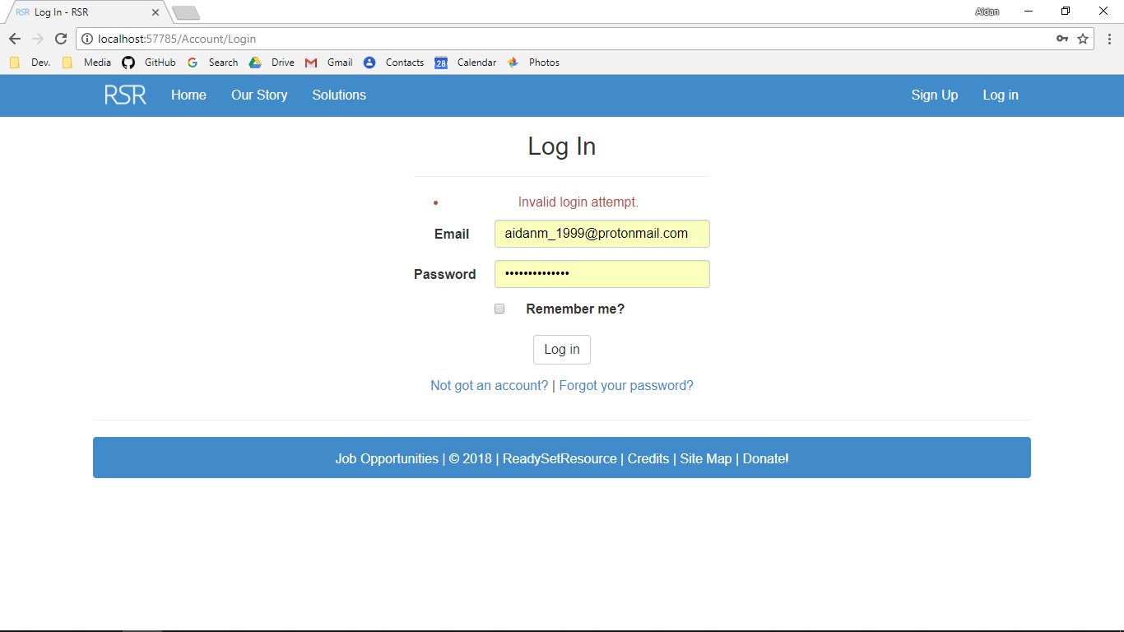

Additional Screenshot (if applicable):

Additional Notes (if applicable):

Test Case ID: HV3 Attempt Number: 1

Action: The user clicks on the Boolean variable and clicks log in

Comprehensive Test Type: Normal

Test Data: Not Applicable

Expected Output: The user logs in and the browser is remembered

Actual Output: As expected

Result: Pass

Reason for fail (if applicable):

Error Type (if applicable):

Remediation (if applicable):

Screenshot Before:

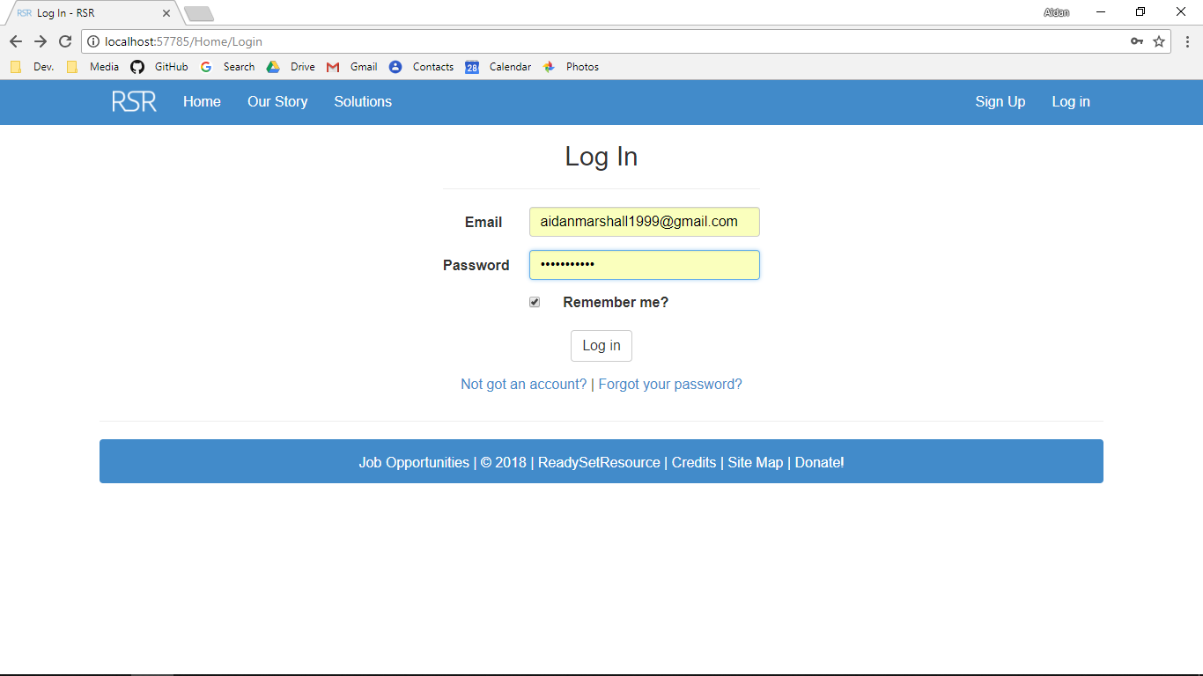

Screenshot After:



Additional Screenshot (if applicable):

Additional Notes (if applicable): As there are only two options both will be tested but both are normal test cases. There cannot be an exceptional or extreme test case for this.

Test Case ID: HV3 Attempt Number: 1

Action: The user does not click on the Boolean variable and clicks log in

Comprehensive Test Type: Normal

Test Data: Not Applicable

Expected Output: The user logs in and the browser is not remembered

Actual Output: As expected

Result: Pass

Reason for fail (if applicable):

Error Type (if applicable):

Remediation (if applicable):

Screenshot Before:

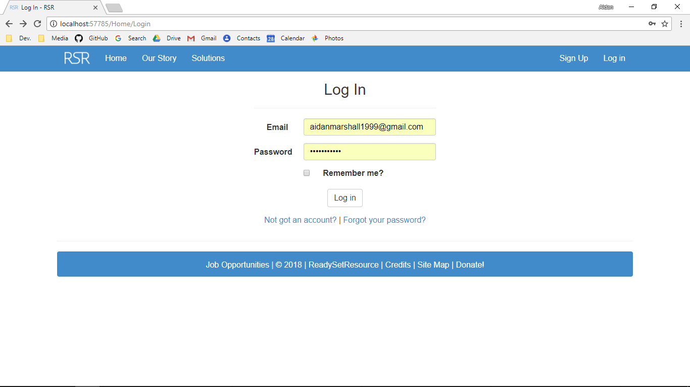

Screenshot After:



Additional Screenshot (if applicable):

Additional Notes (if applicable): As there are only two options both will be tested but both are normal test cases. There cannot be an exceptional or extreme test case for this.

# 30.4 - Test Cases Work Log

| Entry | Description | Person | Date | Mins Spent |
| --- | --- | --- | --- | --- |
| 1 | Formatted the document | Aidan Marshall | 27/5/18 | 38 |
| 2 | Wrote the prepopulated data section | Aidan Marshall | 27/5/18 | 14 |
| 3 | Described the layout of the test cases | Aidan Marshall | 27/5/18 | 32 |
| 4 | Wrote the test log | Aidan Marshall | 27/5/18 | 378 |
| 5 | Prepopulated the site | Aidan Marshall | 28/5/18 | 312 |
| 6 | Completed the test cases | Aidan Marshall | 28/5/18 | 192 |
| 966 | | | | |